ATMA RAM SANATAN DHARMA COLLEGE



SUBMITTED BY

**ISHA GOEL**

**B.Sc (Hons) Computer Science**

**18073**

SUBMITTED TO

**Mr. Lokesh Kumar Shrivastav**

**(Department of Computer Science)**

**INDEX**

1. **Create “Hello World” application that will display “Hello World” in the middle of the screen in the emulator. Also display “Hello World” in the middle of the screen in the android phone.**
2. Create an application to display various android activity lifecycle phases.
3. **Create an application with first activity with an editText and send button. On click of send button, make use of explicit intent to send text to second activity and display there in text view**.
4. Create an application with first activity with an editText and send button. On click of send button, make use of implicit intent that uses a SEND ACTION and let user select app from app chooser and navigate to that application.
5. **Create spinner with strings taken from resource folder (res >> value folder) and on changing the spinner value, Image will change**.
6. Create a menu with 5 options and selected option should appear in text box in upper case.
7. **Create a radio button group with radio button of all courses in your college and on selecting a particular course, teacher-in- charge of that course should appear at the bottom of the screen.**
8. Create a list of all courses in your college and on selecting a particular course parent department and the teacher-in-charge of that department should appear at the bottom of the screen.
9. **a) Create an application with three buttons (with different color names) vertically aligned, on selecting a button color of the screen will change.**

**b) Create an application with three buttons horizontally aligned, on selecting a button color of the screen will change.**

1. Create a Login application (check username and password). On successful login, pop up the message. ("Welcome username")
2. **Create a login application as above, on successful login redirect to another activity with logout button. On click of logout button a dialog appears with OK and CANCEL button. On OK button click go to login activity and on CANCEL stay at same activity.**
3. Create an application to Create, Insert, update and Delete operation on the database

**PRACTICAL 1**

**OBJECTIVE:** Create “Hello World” application that will display “Hello World” in the middle of the screen in the emulator. Also display “Hello World” in the middle of the screen in the android phone.

**CODE**

**Activity_main.xml**

<?xml version="1.0" encoding="utf-8"?>  
<android.support.constraint.ConstraintLayout xmlns:android="http://schemas.android.com/apk/res/android"  
 xmlns:app="http://schemas.android.com/apk/res-auto"  
 xmlns:tools="http://schemas.android.com/tools"  
 android:layout_width="match_parent"  
 android:layout_height="match_parent"  
 tools:context=".MainActivity">  
  
 <TextView  
 android:layout_width="wrap_content"  
 android:layout_height="wrap_content"  
 android:text="Hello World!"  
 app:layout_constraintBottom_toBottomOf="parent"  
 app:layout_constraintEnd_toEndOf="parent"  
 app:layout_constraintStart_toStartOf="parent"  
 app:layout_constraintTop_toTopOf="parent" />  
  
</android.support.constraint.ConstraintLayout>

**MainActivity.java**

package com.example.p1;  
  
import android.support.v7.app.AppCompatActivity;  
import android.os.Bundle;  
  
public class MainActivity extends AppCompatActivity {  
  
 @Override  
 protected void onCreate(Bundle savedInstanceState) {  
 super.onCreate(savedInstanceState);  
 setContentView(R.layout.*activity_main*);  
 }  
}

**OUTPUT:**

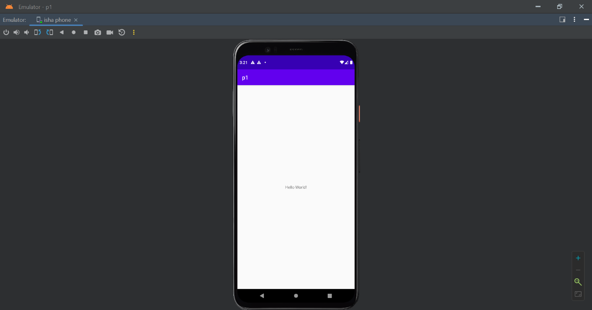

**PRACTICAL 2**

**OBJECTIVE:** Create an application to display various android activity lifecycle phases.

**CODE**

**Activity_main.xml**

<?xml version="1.0" encoding="utf-8"?>  
<androidx.constraintlayout.widget.ConstraintLayout  
 xmlns:android="http://schemas.android.com/apk/res/android"  
 xmlns:app="http://schemas.android.com/apk/res-auto"  
 xmlns:tools="http://schemas.android.com/tools"  
 android:layout_width="match_parent"  
 android:layout_height="match_parent"  
 tools:context=".MainActivity">  
  
 <TextView  
 android:id="@+id/Display"  
 android:layout_width="0dp"  
 android:layout_height="wrap_content"  
 android:layout_marginLeft="100dp"  
 android:layout_marginBottom="250dp"  
 android:fontFamily="sans-serif-black"  
 android:text="activity_life_cycle"  
 android:textAppearance="@style/TextAppearance.AppCompat.Large"  
 android:textColor="@color/purple_500"  
 android:textColorHighlight="@color/black"  
 android:textSize="50sp"  
 android:textStyle="bold|italic"  
 android:typeface="monospace"  
 app:layout_constraintBottom_toBottomOf="parent"  
 app:layout_constraintEnd_toEndOf="parent"  
 app:layout_constraintLeft_toLeftOf="parent"  
 app:layout_constraintRight_toRightOf="parent"  
 app:layout_constraintTop_toTopOf="parent"  
 app:layout_constraintVertical_bias="1.0" />  
  
  
</androidx.constraintlayout.widget.ConstraintLayout>

**MainActivity.java**

package com.example.p2;  
  
import androidx.appcompat.app.AppCompatActivity;  
  
import android.os.Bundle;  
import android.widget.Toast;  
public class MainActivity extends AppCompatActivity {  
 @Override  
 protected void onCreate(Bundle savedInstanceState) {  
 super.onCreate(savedInstanceState);  
 setContentView(R.layout.*activity_main*);  
 Toast t = Toast.*makeText*(getApplicationContext(), "Activity Created",  
 Toast.*LENGTH_SHORT*);  
 t.show();  
 }  
 @Override  
 protected void onResume() {  
 super.onResume();  
 Toast t = Toast.*makeText*(getApplicationContext(), "Activity Resumed",  
 Toast.*LENGTH_SHORT*);  
 t.show();  
 }  
 @Override  
 protected void onPause() {  
 super.onPause();  
 Toast t = Toast.*makeText*(getApplicationContext(), "Activity Paused",  
 Toast.*LENGTH_SHORT*);  
 t.show();  
 }  
 @Override  
 protected void onStart() {  
 super.onStart();  
 Toast t = Toast.*makeText*(getApplicationContext(), "Activity Started",  
 Toast.*LENGTH_SHORT*);  
 t.show();  
 }  
 @Override  
 protected void onStop() {  
 super.onStop();  
 Toast t = Toast.*makeText*(getApplicationContext(), "Activity Stopped",  
 Toast.*LENGTH_SHORT*);  
 t.show();  
 }  
 @Override  
 protected void onDestroy() {  
 super.onDestroy();  
 Toast t = Toast.*makeText*(getApplicationContext(), "Activity Destroyed",  
 Toast.*LENGTH_SHORT*);  
 t.show();  
 }  
}

**OUTPUT**

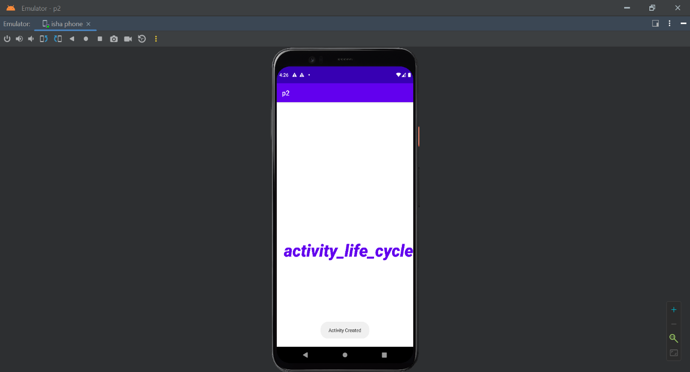

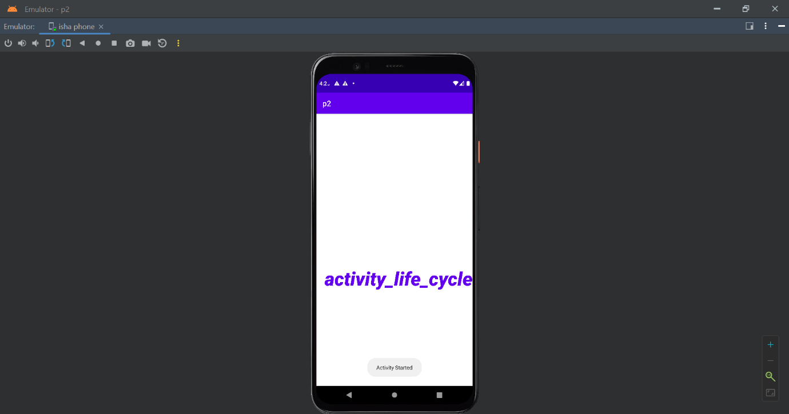

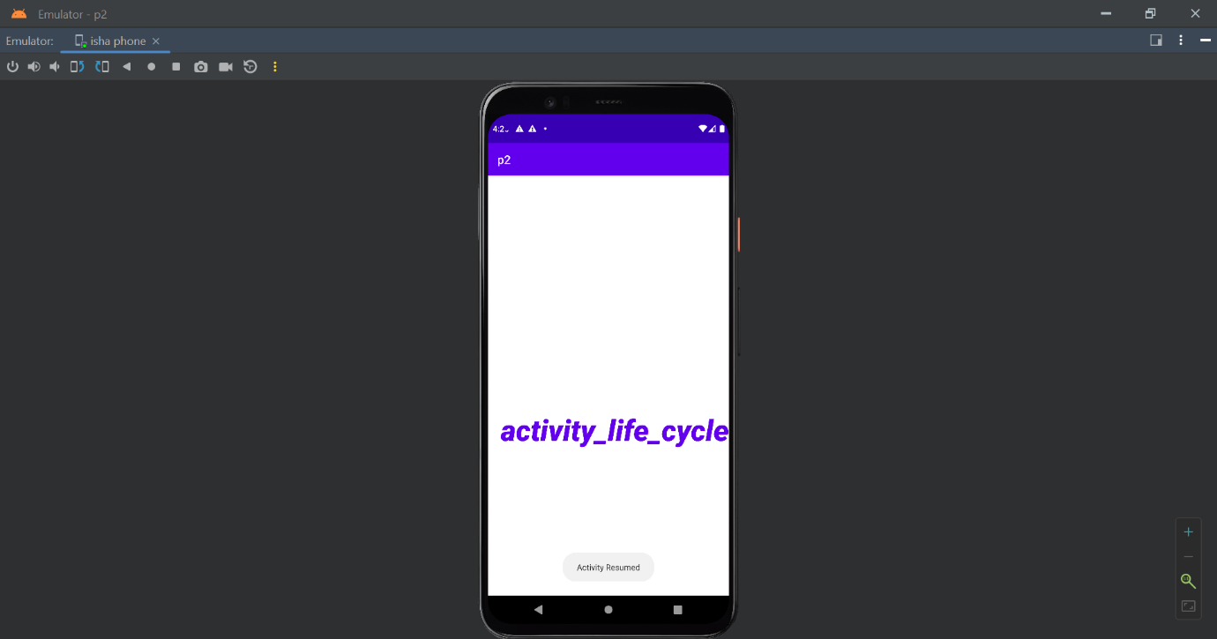

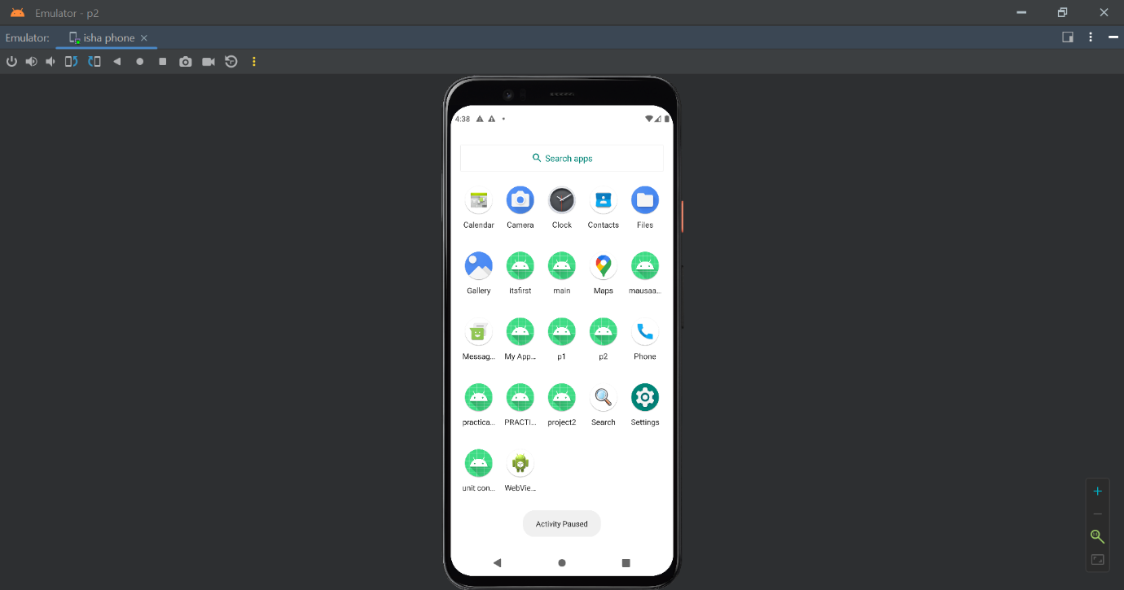

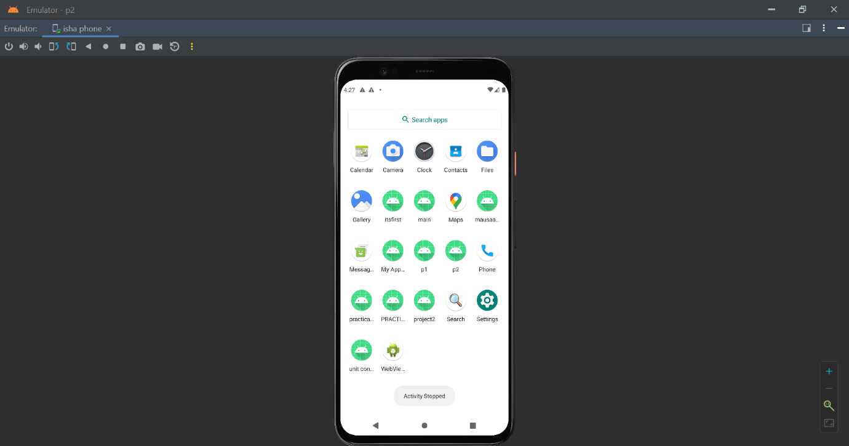

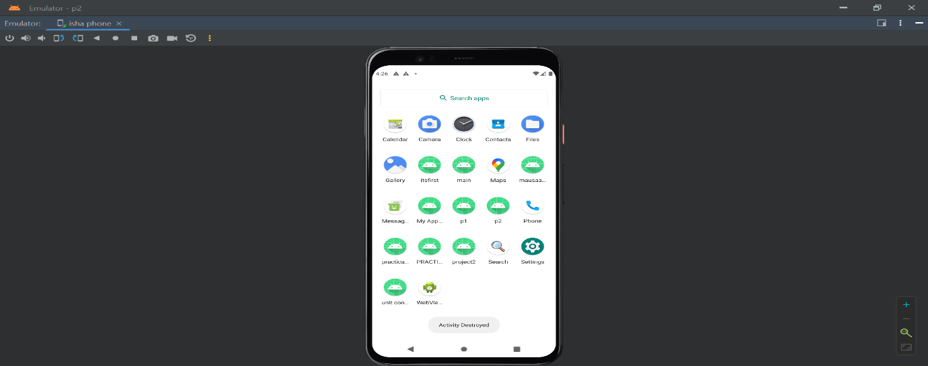

**PRACTICAL 3**

**OBJECTIVE:** Create an application with first activity with an editText and send button. On click of send button, make use of explicit intent to send text to second activity and display there in text view.

**CODE:**

**ACTIVITY_MAIN.XML**

<?xml version="1.0" encoding="utf-8"?>  
<RelativeLayout xmlns:android="http://schemas.android.com/apk/res/android"  
 xmlns:app="http://schemas.android.com/apk/res-auto"  
 xmlns:tools="http://schemas.android.com/tools"  
 android:layout_width="match_parent"  
 android:layout_height="match_parent"  
 tools:context=".MainActivity"  
 android:padding="20sp">  
 <EditText  
 android:layout_width="match_parent"  
 android:layout_height="wrap_content"  
 android:hint="Type Something"  
 android:id="@+id/edittext"  
 />  
 <Button  
 android:layout_width="match_parent"  
 android:layout_height="wrap_content"  
 android:text="Submit"  
 android:textSize="20sp"  
 android:layout_below="@+id/edittext"  
 android:id="@+id/button"/>  
</RelativeLayout>

**ACTIVITYMAIN.JAVA**

package com.example.practical3;  
import androidx.appcompat.app.AppCompatActivity;  
import android.content.Intent;  
import android.os.Bundle;  
import android.view.View;  
import android.widget.Button;  
import android.widget.EditText;  
public class MainActivity extends AppCompatActivity {  
 Button btn;  
 EditText et;  
 String st;  
 @Override  
 protected void onCreate(Bundle savedInstanceState) {  
 super.onCreate(savedInstanceState);  
 setContentView(R.layout.*activity_main*);  
 btn=findViewById(R.id.*button*);  
 et=findViewById(R.id.*edittext*);  
 btn.setOnClickListener(new View.OnClickListener(){  
 @Override  
 public void onClick(View v){  
 Intent i=new Intent(MainActivity.this,display.class);  
 st=et.getText().toString();  
 i.putExtra("Value",st);  
 startActivity(i);  
 finish();  
 }  
 });  
 }  
}

**Activity_display.xml**

<?xml version="1.0" encoding="utf-8"?>  
<RelativeLayout xmlns:android="http://schemas.android.com/apk/res/android"  
 xmlns:app="http://schemas.android.com/apk/res-auto"  
 xmlns:tools="http://schemas.android.com/tools"  
 android:layout_width="match_parent"  
 android:layout_height="match_parent"  
 tools:context=".display">  
 <TextView  
 android:id="@+id/textView"  
 android:layout_width="match_parent"  
 android:layout_height="match_parent"  
 android:gravity="center"  
 android:text="Value"  
 android:textColor="@color/purple_200"  
 android:textSize="50sp"  
 android:textStyle="bold" />  
</RelativeLayout>

**Display.java**

package com.example.practical3;  
import androidx.appcompat.app.AppCompatActivity;  
import android.os.Bundle;  
import android.widget.TextView;  
public class display extends AppCompatActivity {  
 TextView tv;  
 String st;  
 @Override  
 protected void onCreate(Bundle savedInstanceState) {  
 super.onCreate(savedInstanceState);  
 setContentView(R.layout.*activity_display*);  
 tv=findViewById(R.id.*textView*);  
 st=getIntent().getExtras().getString("Value");  
 tv.setText(st);  
 }  
}

**OUTPUT**

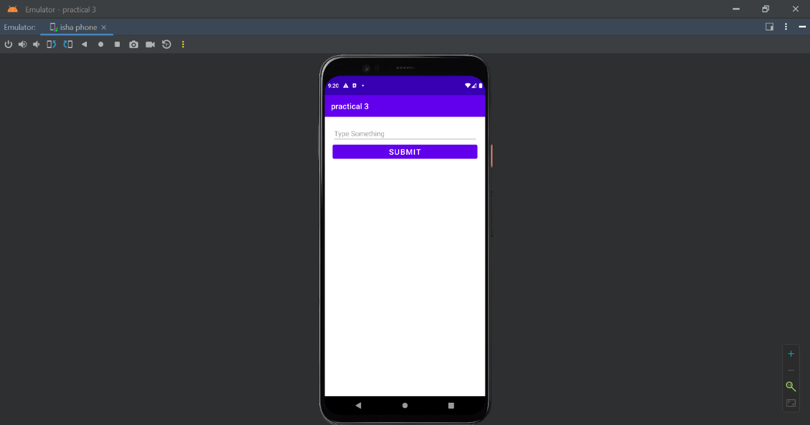

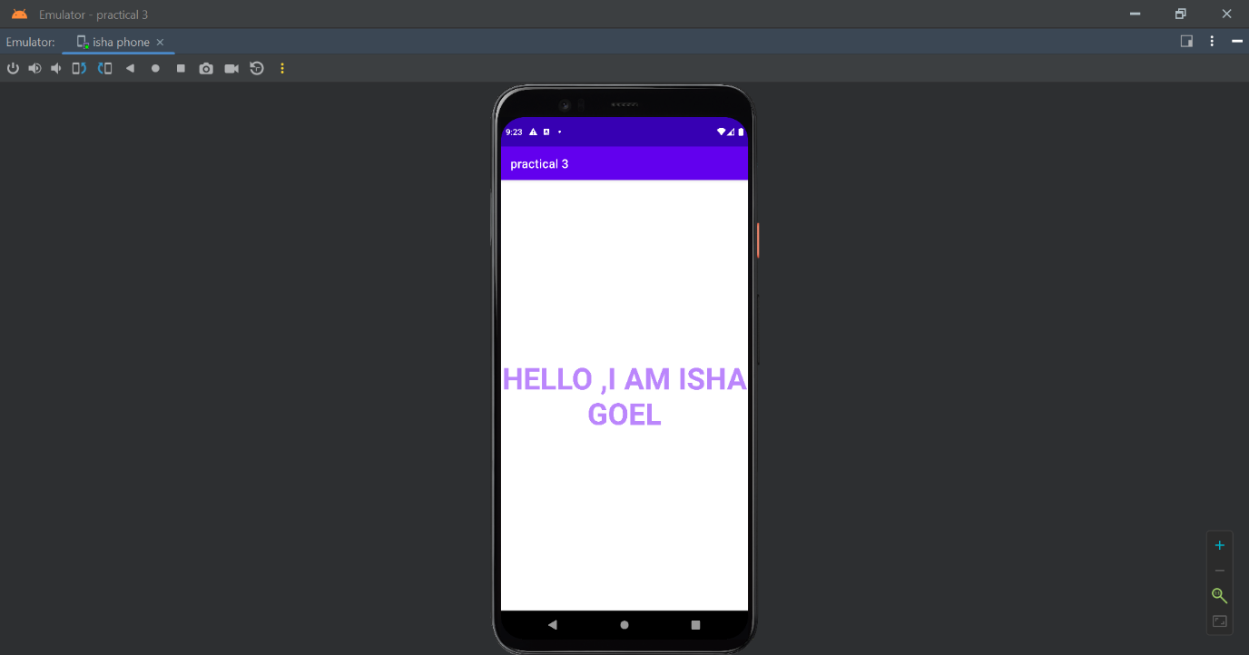

**PRACTICAL 4**

**OBJECTIVE:** Create an application with first activity with an editText and send button. On click of send button, make use of implicit intent that uses a SEND ACTION and let user select app from app chooser and navigate to that application.

**CODE**

Activity_main.xml

<?xml version="1.0" encoding="utf-8"?>  
<androidx.constraintlayout.widget.ConstraintLayout xmlns:android="http://schemas.android.com/apk/res/android"  
 xmlns:app="http://schemas.android.com/apk/res-auto"  
 xmlns:tools="http://schemas.android.com/tools"  
 android:layout_width="match_parent"  
 android:layout_height="match_parent"  
 tools:context=".MainActivity">  
 <Button  
 android:id="@+id/btnShare"  
 android:layout_width="wrap_content"  
 android:layout_height="wrap_content"  
 android:text="Share Text"  
 app:layout_constraintBottom_toBottomOf="parent"  
 app:layout_constraintLeft_toLeftOf="parent"  
 app:layout_constraintRight_toRightOf="parent"  
 app:layout_constraintTop_toTopOf="parent" />  
  
  
  
   
  
</androidx.constraintlayout.widget.ConstraintLayout>

**MainActivity.java**

package com.example.practical4;  
  
import androidx.appcompat.app.AppCompatActivity;  
  
import android.content.Intent;  
import android.os.Bundle;  
import android.view.View;  
import android.widget.Button;  
public class MainActivity extends AppCompatActivity {  
 @Override  
 protected void onCreate(Bundle savedInstanceState) {  
 super.onCreate(savedInstanceState);  
 setContentView(R.layout.*activity_main*);  
 Button btnShare=findViewById(R.id.*btnShare*);  
 btnShare.setOnClickListener(new View.OnClickListener() {  
 @Override  
 public void onClick(View v) {  
 Intent intent=new Intent(Intent.*ACTION_SEND*);  
 intent.setType("text/plain");  
 intent.putExtra(Intent.*EXTRA_TEXT*,"Hello There,I AM ISHA GOEL");  
 startActivity(intent.*createChooser*(intent,"Share"));  
 }  
 });  
 }  
}

**OUTPUT**

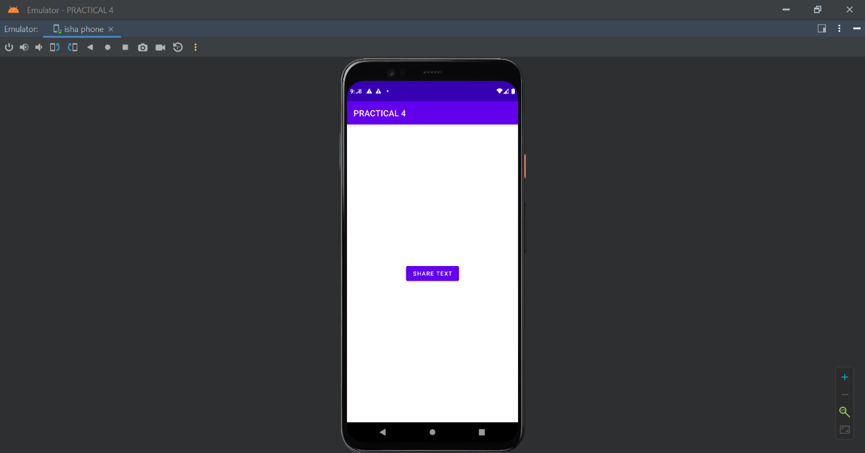

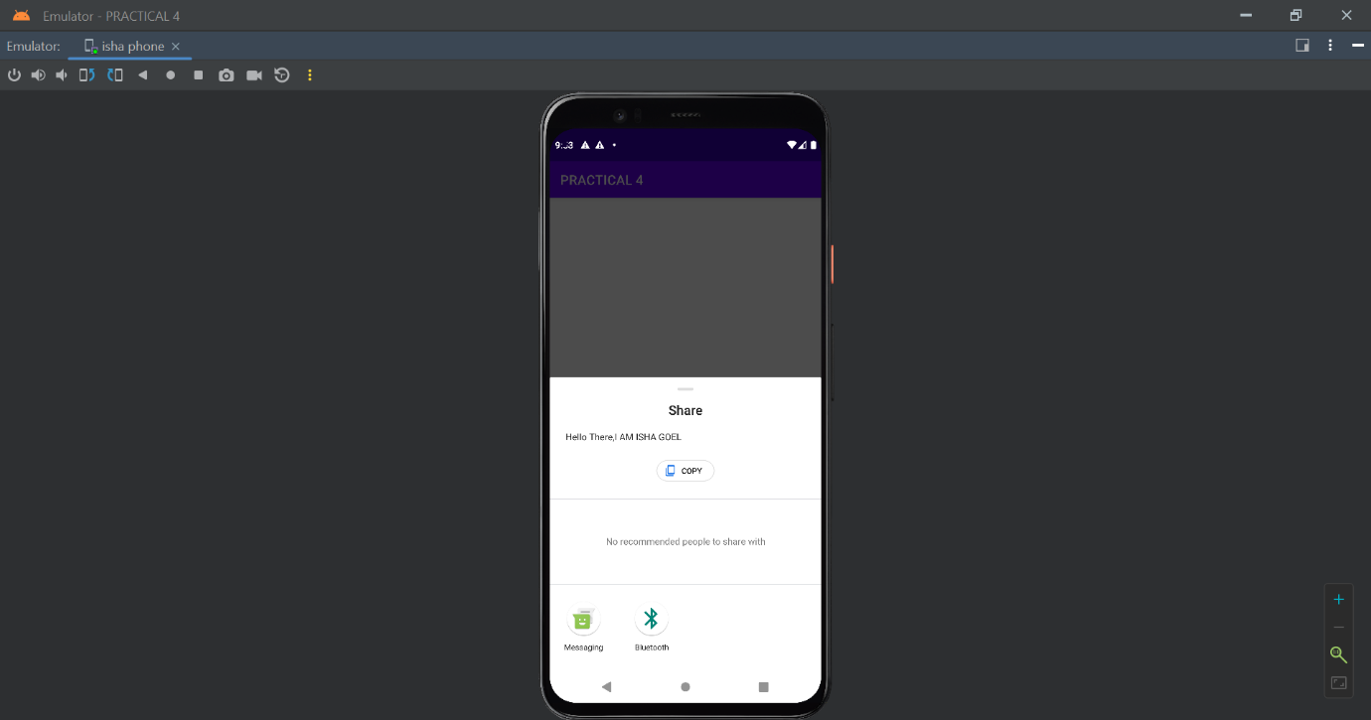

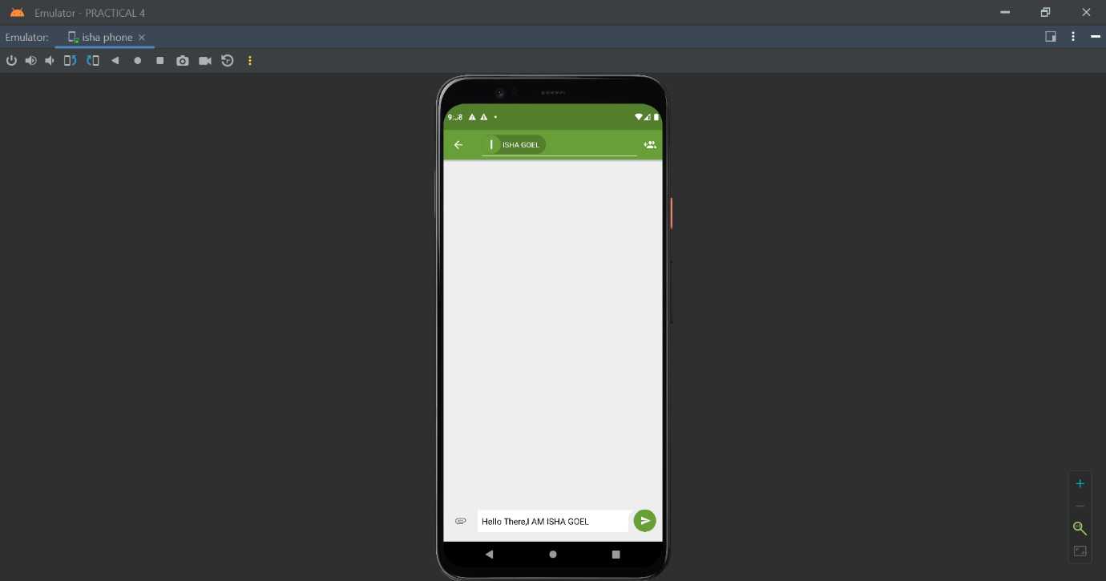

**PRACTICAL 5**

**OBJECTIVE:** Create spinner with strings taken from resource folder (res >> value folder) and on changing the spinner value, Image will change.

**CODE**

**Activity_main.xml**

<?xml version="1.0" encoding="utf-8"?>  
<androidx.constraintlayout.widget.ConstraintLayout xmlns:android="http://schemas.android.com/apk/res/android"  
 xmlns:app="http://schemas.android.com/apk/res-auto"  
 xmlns:tools="http://schemas.android.com/tools"  
 android:layout_width="match_parent"  
 android:layout_height="match_parent"  
 tools:context=".MainActivity">  
 <Spinner  
 android:id="@+id/spinner"  
 android:layout_width="0dp"  
 android:layout_height="wrap_content"  
 android:layout_marginStart="8dp"  
 android:layout_marginLeft="8dp"  
 android:layout_marginTop="16dp"  
 android:layout_marginEnd="8dp"  
 android:layout_marginRight="8dp"  
 app:layout_constraintEnd_toEndOf="parent"  
 app:layout_constraintStart_toStartOf="parent"  
 app:layout_constraintTop_toTopOf="parent"  
 />  
 <ImageView  
 android:id="@+id/image"  
 android:layout_width="332dp"  
 android:layout_height="323dp"  
 app:layout_constraintBottom_toBottomOf="parent"  
 app:layout_constraintEnd_toEndOf="parent"  
 app:layout_constraintStart_toStartOf="parent"  
 app:layout_constraintTop_toTopOf="@+id/spinner"  
 app:layout_constraintVertical_bias="0.479" />  
  
</androidx.constraintlayout.widget.ConstraintLayout>

**MainActivity.java**

package com.example.spinner;  
  
import androidx.appcompat.app.AppCompatActivity;  
  
import android.os.Bundle;  
  
import android.view.View;  
import android.widget.AdapterView;  
import android.widget.ArrayAdapter;  
import android.widget.ImageView;  
import android.widget.Spinner;  
public class MainActivity extends AppCompatActivity {  
 private Spinner spinner;  
 private ImageView image;  
 @Override  
 protected void onCreate(Bundle savedInstanceState) {  
 super.onCreate(savedInstanceState);  
 setContentView(R.layout.*activity_main*);  
 spinner=findViewById(R.id.*spinner*);  
 image=findViewById(R.id.*image*);  
 String [] ARSD={"Select One","AP TEACHER","DAA TEACHER","DBMS TEACHER","JAVA TEACHER"};  
 ArrayAdapter<String>adapter=new  
 ArrayAdapter<String>(this,android.R.layout.*simple_spinner_dropdown_item*,ARSD);  
 spinner.setAdapter(adapter);  
 spinner.setOnItemSelectedListener(new AdapterView.OnItemSelectedListener()  
 {  
 @Override  
 public void onItemSelected(AdapterView<?> parent, View view, int  
 position, long id) {  
 switch (position){  
 case 1:  
 image.setImageResource(R.drawable.*sir*);  
 break;  
 case 2:  
 image.setImageResource(R.drawable.*daa*);  
 break;  
 case 3:  
 image.setImageResource(R.drawable.*dbms*);  
 break;  
 case 4:  
 image.setImageResource(R.drawable.*java*);  
 break;  
 }  
 }  
 @Override  
 public void onNothingSelected(AdapterView<?> parent) {  
 }  
 });  
 }  
}

**OUTPUT**

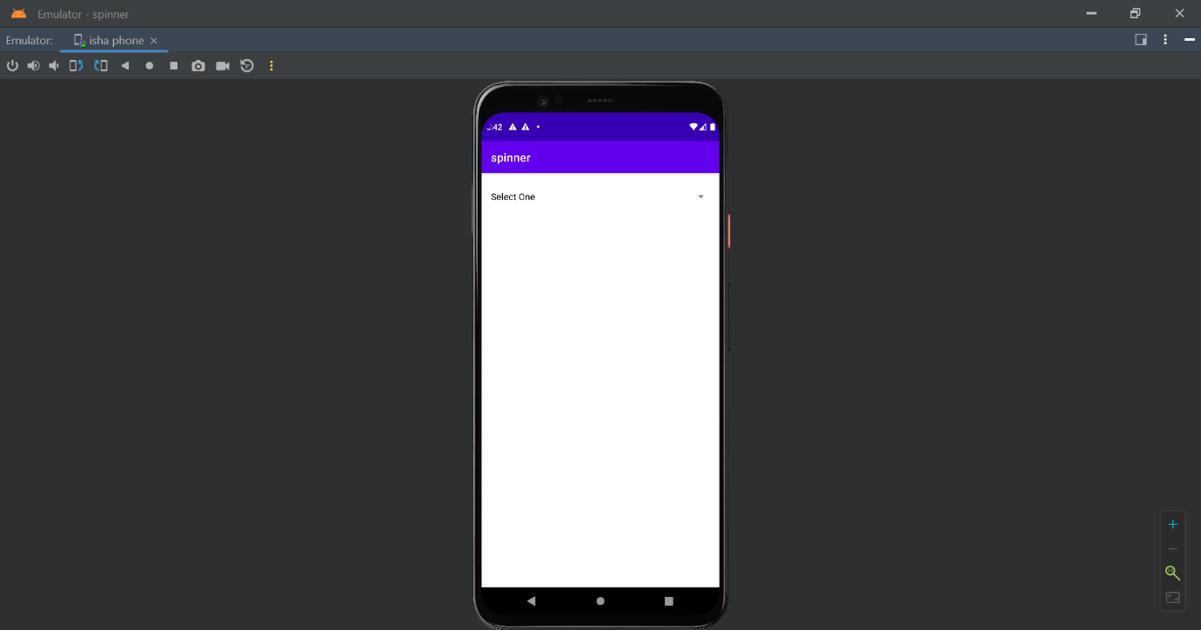

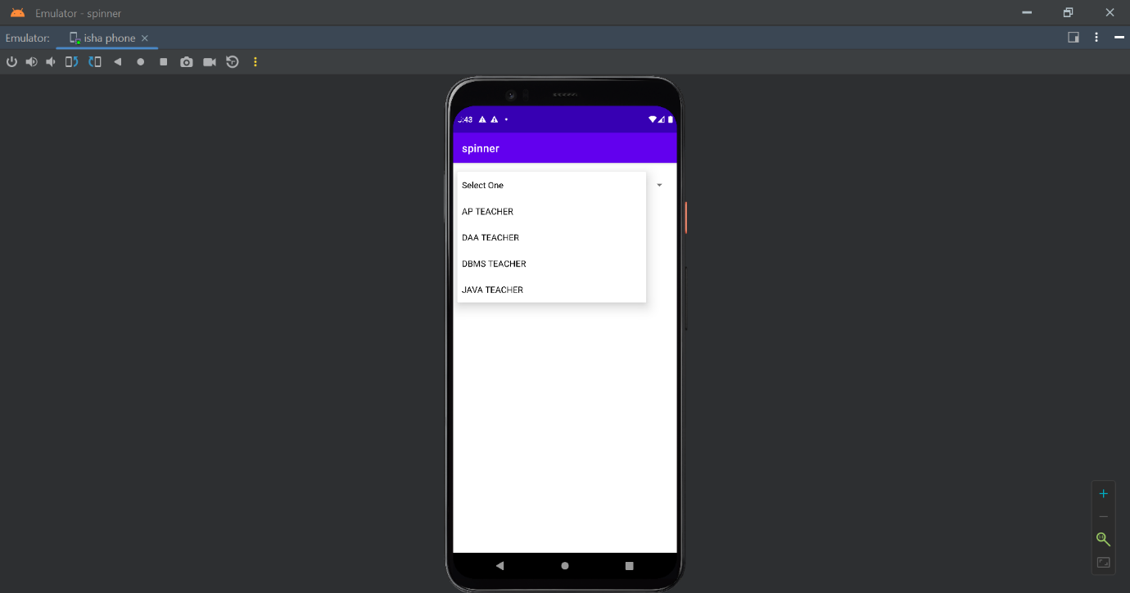

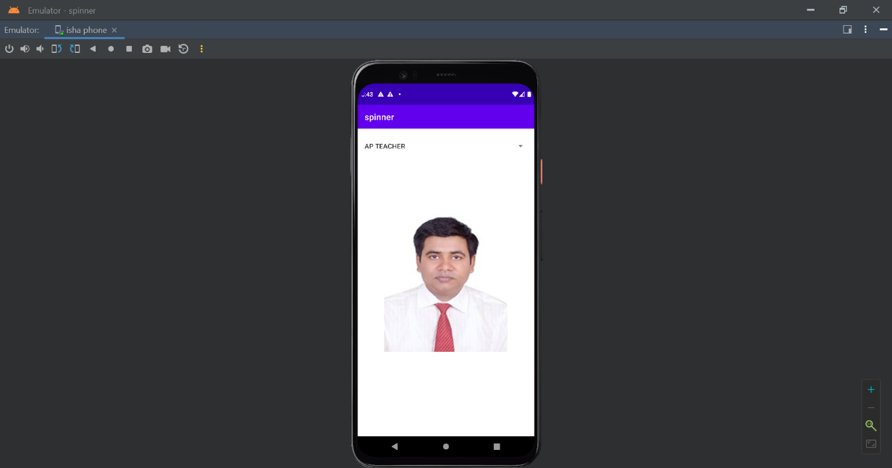

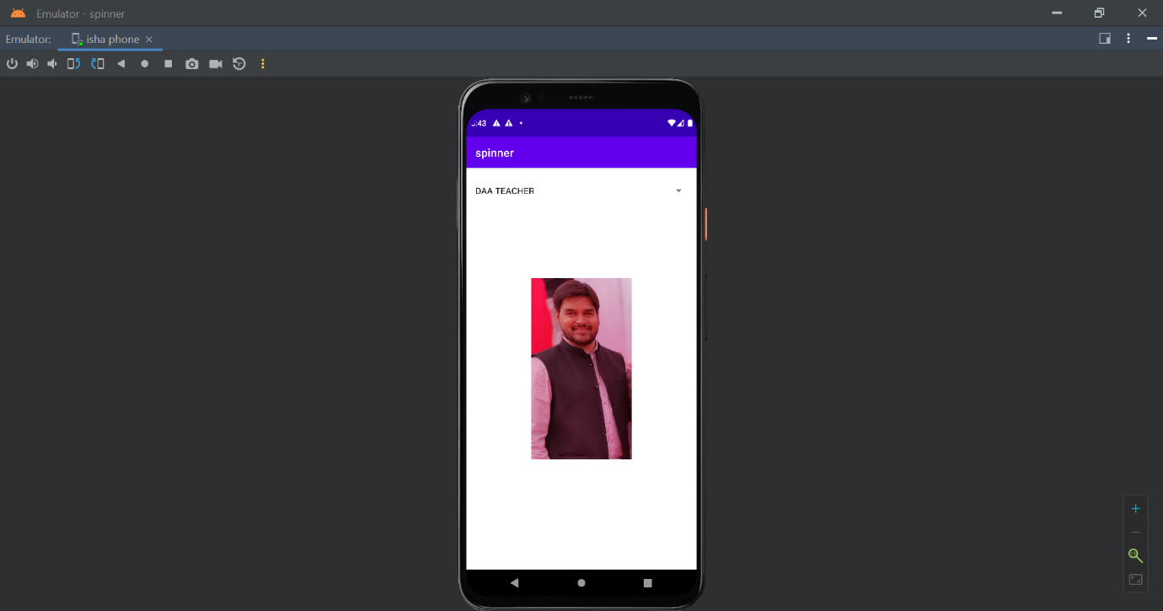

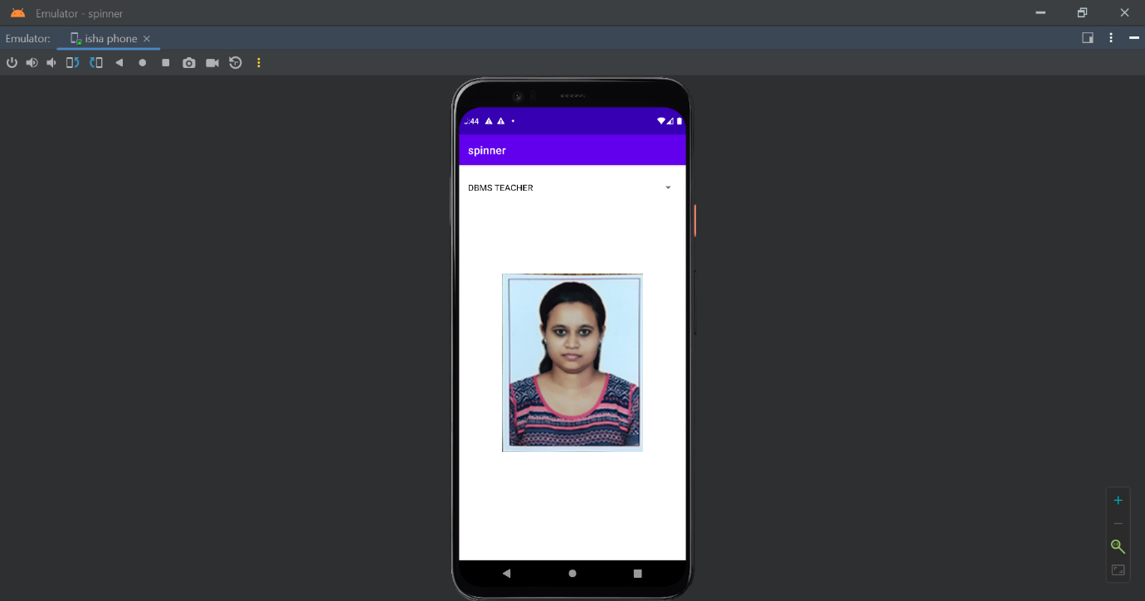

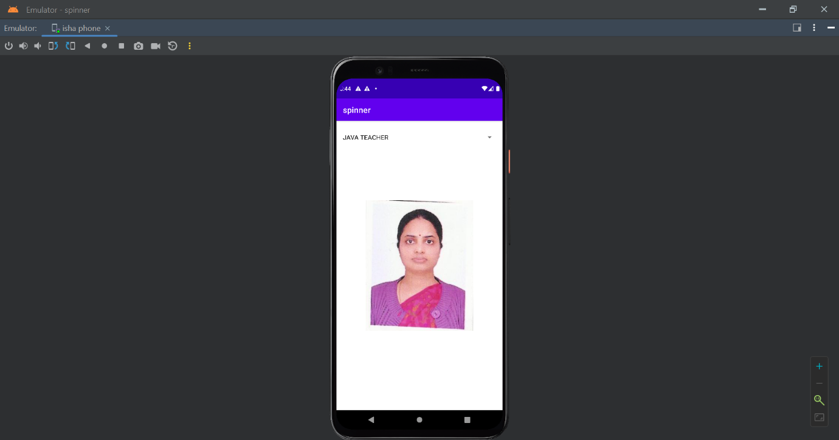

**PRACTICAL 6**

**OBJECTIVE:** Create a menu with 5 options and selected option should appear in text box in upper case.

**CODE**

**Activity_main.xml**

<?xml version="1.0" encoding="utf-8"?>  
<androidx.constraintlayout.widget.ConstraintLayout  
 xmlns:android="http://schemas.android.com/apk/res/android"  
 xmlns:app="http://schemas.android.com/apk/res-auto"  
 xmlns:tools="http://schemas.android.com/tools"  
 android:layout_width="match_parent"  
 android:layout_height="match_parent"  
 tools:context=".MainActivity">  
 <RelativeLayout  
 android:layout_width="match_parent"  
 android:layout_height="match_parent"  
 android:layout_margin="80dp"  
 app:layout_constraintBottom_toBottomOf="parent"  
 app:layout_constraintLeft_toLeftOf="parent"  
 app:layout_constraintRight_toRightOf="parent"  
 app:layout_constraintTop_toTopOf="parent">  
 <EditText  
 android:layout_width="match_parent"  
 android:layout_height="wrap_content"  
 android:id="@+id/etMenuItem"  
 android:layout_centerInParent="true"  
 android:hint="Select an Option from the Menu"  
 android:textAlignment="center"  
 android:gravity="center_horizontal" />  
 </RelativeLayout>  
</androidx.constraintlayout.widget.ConstraintLayout>

**Mainactivity.java**

package com.example.practical6ap;  
  
import androidx.appcompat.app.AppCompatActivity;  
  
import android.os.Bundle;  
import android.view.Menu;  
import android.view.MenuInflater;  
import android.view.MenuItem;  
import android.widget.EditText;  
  
public class MainActivity extends AppCompatActivity {  
 private EditText etMenuItem;  
 @Override  
 protected void onCreate(Bundle savedInstanceState) {  
 super.onCreate(savedInstanceState);  
 setContentView(R.layout.*activity_main*);  
 etMenuItem=(EditText) findViewById(R.id.*etMenuItem*);  
 }  
 @Override  
 public boolean onCreateOptionsMenu(Menu menu){  
 MenuInflater inflater=getMenuInflater();  
 inflater.inflate(R.menu.*main_menu*,menu);  
 return true;  
 }  
 @Override  
 public boolean onOptionsItemSelected(MenuItem item){  
 etMenuItem.setText(item.getTitle().toString().toUpperCase());  
 return super.onOptionsItemSelected(item);  
 }  
}

**main_menu.xml**

<?xml version="1.0" encoding="utf-8"?>  
<menu xmlns:android="http://schemas.android.com/apk/res/android">  
 <item  
 android:id="@+id/miSettings"  
 android:title="settings" />  
 <item  
 android:id="@+id/miBackup"  
 android:title="backup" />  
 <item  
 android:id="@+id/miReset"  
 android:title="reset" />  
 <item  
 android:id="@+id/miAbout"  
 android:title="about" />  
 <item  
 android:id="@+id/miHelp"  
 android:title="help" />  
 </menu>

**OUTPUT**

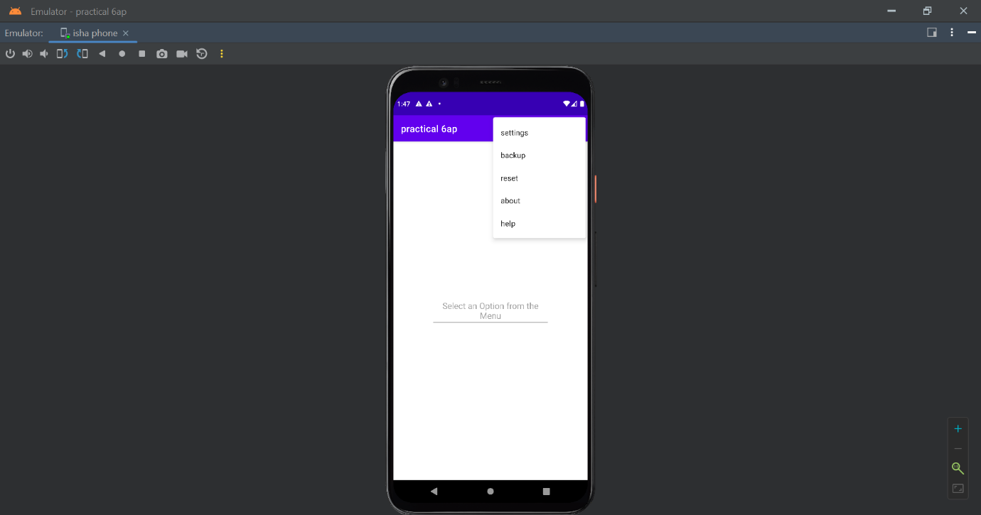

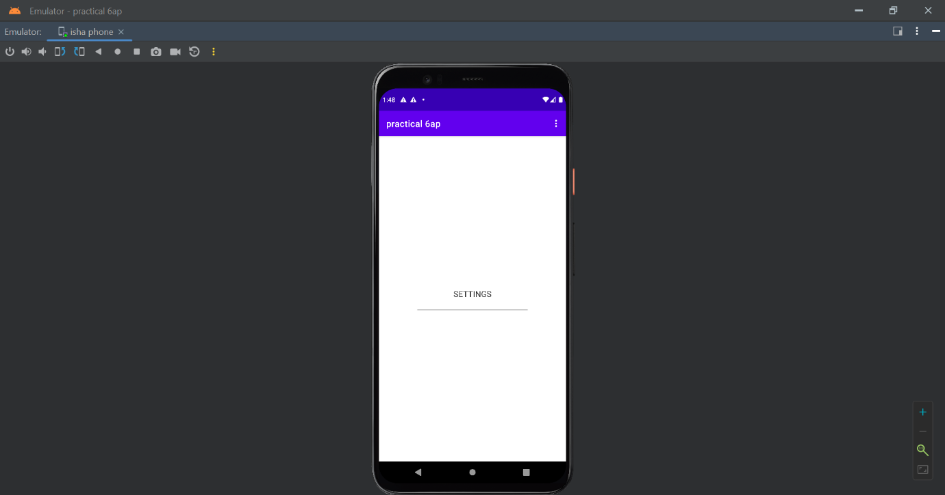

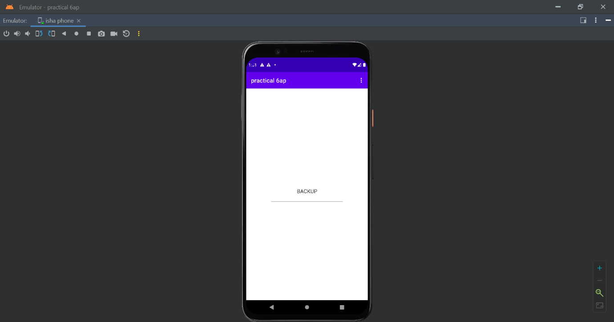

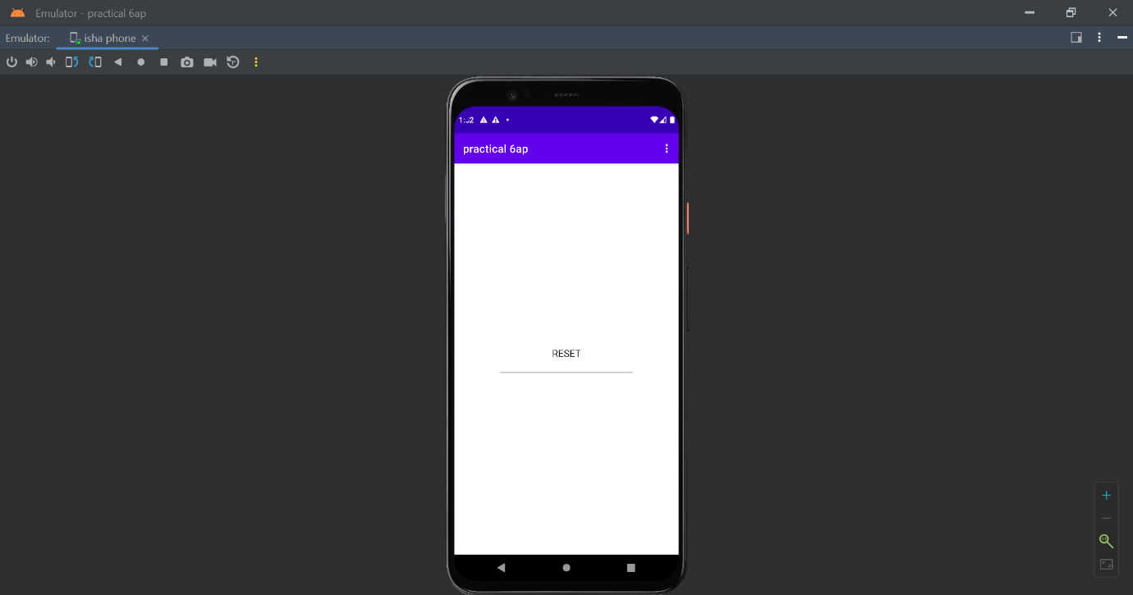

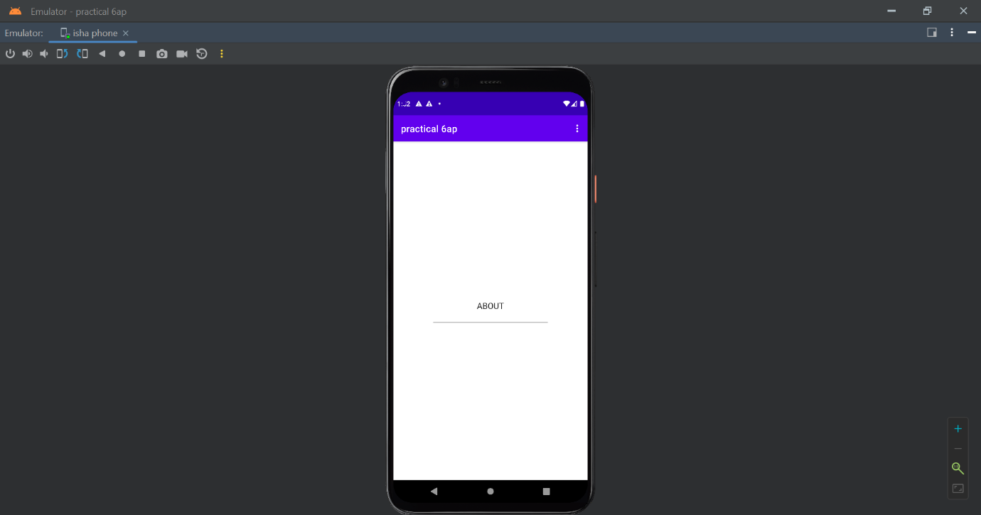

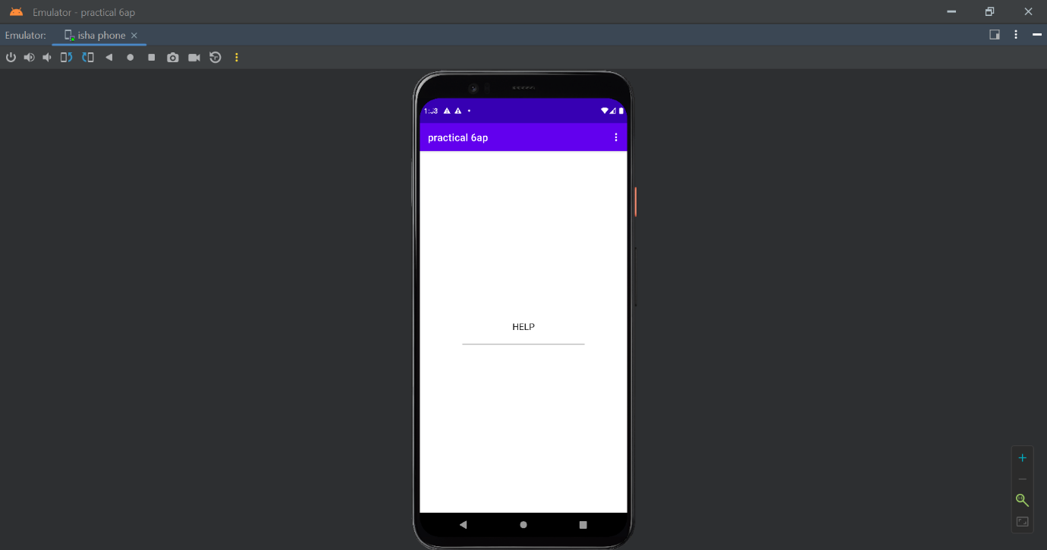

**PRACTICAL 7**

**OBJECTIVE:Create a radio button group with radio button of all courses in your college and on selecting a particular course, teacher-in- charge of that course should appear at the bottom of the screen.**

**Activity_main.xml**

<?xml version="1.0" encoding="utf-8"?>  
<androidx.constraintlayout.widget.ConstraintLayout xmlns:android="http://schemas.android.com/apk/res/android"  
 xmlns:app="http://schemas.android.com/apk/res-auto"  
 xmlns:tools="http://schemas.android.com/tools"  
 android:layout_width="match_parent"  
 android:layout_height="match_parent"  
 tools:context=".MainActivity">  
  
 <RelativeLayout  
 android:layout_width="match_parent"  
 android:layout_height="match_parent"  
 android:layout_margin="75dp"  
 app:layout_constraintBottom_toBottomOf="parent"  
 app:layout_constraintLeft_toLeftOf="parent"  
 app:layout_constraintRight_toRightOf="parent"  
 app:layout_constraintTop_toTopOf="parent" >  
  
 <RadioGroup  
 android:layout_width="match_parent"  
 android:layout_height="wrap_content"  
 android:id="@+id/rgCourses"  
 android:layout_centerInParent="true">  
 </RadioGroup>  
 </RelativeLayout>  
</androidx.constraintlayout.widget.ConstraintLayout>

**mainActivity.java**

package com.example.practical7ap;  
  
import androidx.appcompat.app.AppCompatActivity;  
  
import android.os.Bundle;  
import android.provider.MediaStore;  
import android.widget.RadioGroup;  
import android.widget.RadioButton;  
import com.google.android.material.snackbar.Snackbar;  
import java.util.HashMap;  
  
public class MainActivity extends AppCompatActivity {  
 private RadioGroup rgCourses;  
 private HashMap<String, String> coursesMap;  
  
 @Override  
 protected void onCreate(Bundle savedInstanceState) {  
 super.onCreate(savedInstanceState);  
 setContentView(R.layout.*activity_main*);  
 initCourses();  
 }  
 private void initCourses(){  
 rgCourses=(RadioGroup)findViewById(R.id.*rgCourses*);  
 if (coursesMap==null){  
 coursesMap=new HashMap<>();  
 coursesMap.put("BSc(H) Computer Science"," Dr.V.S.Dixit");  
 coursesMap.put("BCom(H)"," Dr.Manika Jain");  
 coursesMap.put("BA(H) Sociology"," Dr. Apra Sinha");  
 for (String course : coursesMap.keySet()){  
 RadioButton rButton=new RadioButton(MainActivity.this);  
 rButton.setText(course);  
 rgCourses.addView(rButton);  
 }  
 rgCourses.setOnCheckedChangeListener(new RadioGroup.OnCheckedChangeListener() {  
 @Override  
 public void onCheckedChanged(RadioGroup group, int checkedId) {  
 int checkedRadioButtonId=rgCourses.getCheckedRadioButtonId();  
 RadioButton rButton=(RadioButton) findViewById(checkedRadioButtonId);  
  
 Snackbar.*make*(rgCourses,coursesMap.get(rButton.getText()),Snackbar.*LENGTH_SHORT*)  
 .show();  
 }  
 });  
 }  
 }  
}

**OUTPUT**

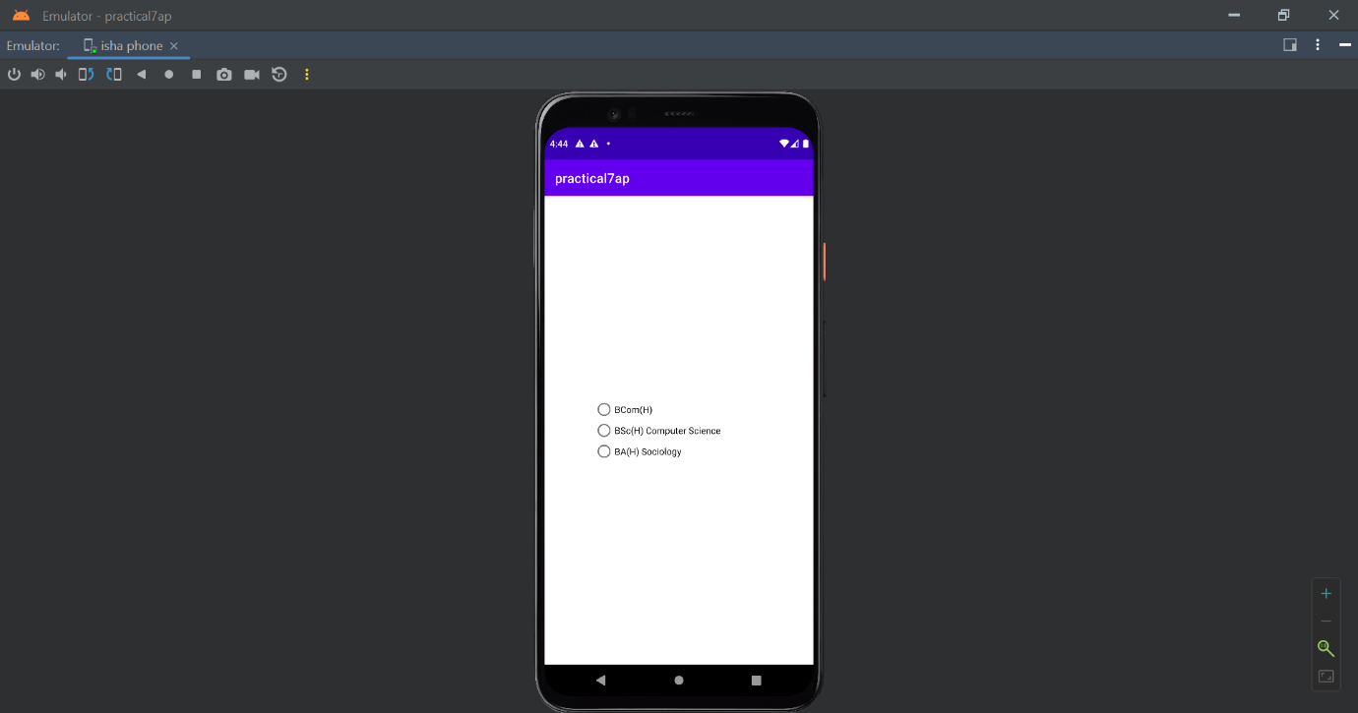

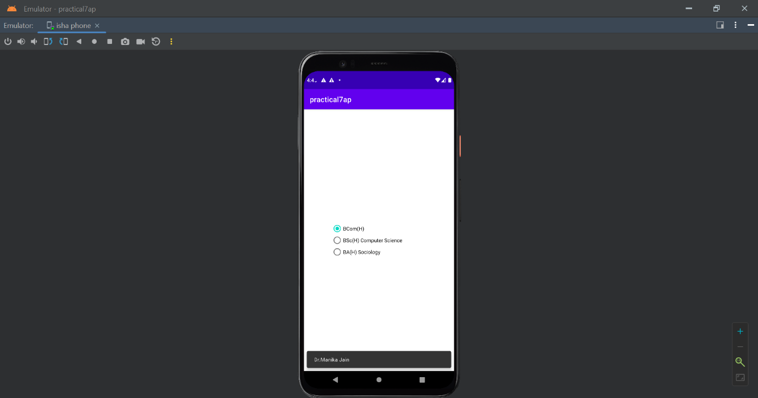

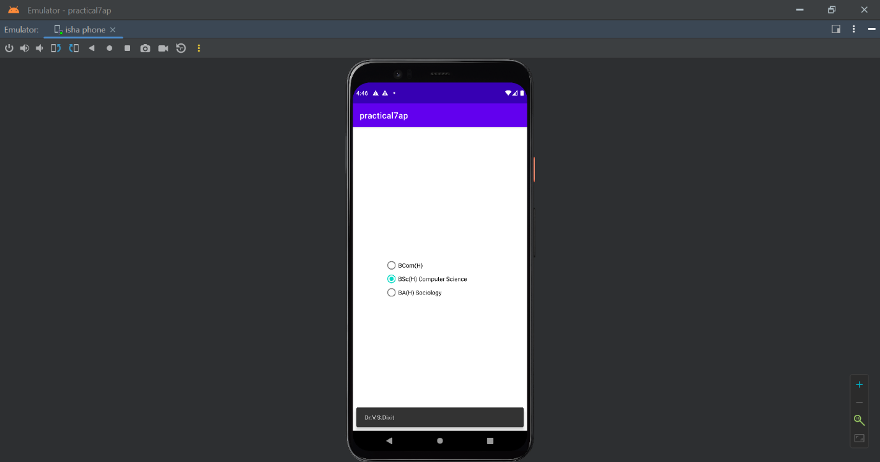

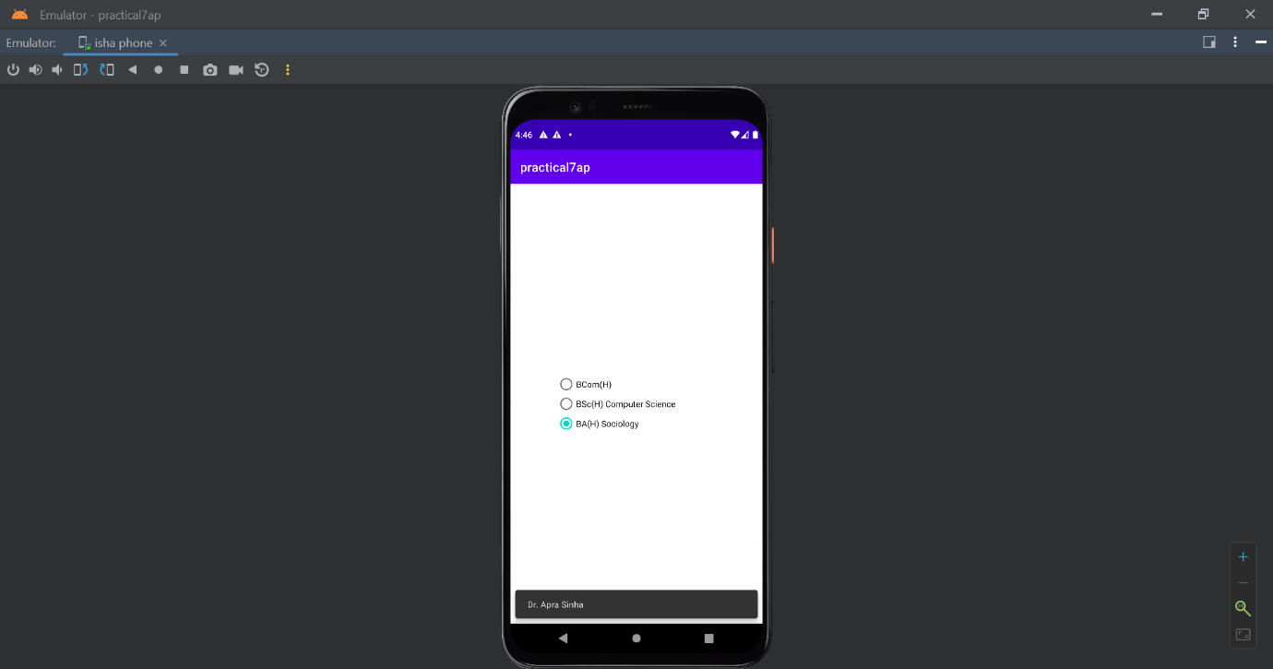

**PRACTICAL 8**

**OBJECTIVE: Create a list of all courses in your college and on selecting a particular course parent department and the teacher-in-charge of that department should appear at the bottom of the screen.**

**mainActivity.java**

package com.example.practical7ap;  
  
import androidx.appcompat.app.AppCompatActivity;  
  
import android.os.Bundle;  
import android.provider.MediaStore;  
import android.widget.RadioGroup;  
import android.widget.RadioButton;  
import com.google.android.material.snackbar.Snackbar;  
import java.util.HashMap;  
  
public class MainActivity extends AppCompatActivity {  
 private RadioGroup rgCourses;  
 private HashMap<String, String> coursesMap;  
  
 @Override  
 protected void onCreate(Bundle savedInstanceState) {  
 super.onCreate(savedInstanceState);  
 setContentView(R.layout.*activity_main*);  
 initCourses();  
 }  
 private void initCourses(){  
 rgCourses=(RadioGroup)findViewById(R.id.*rgCourses*);  
 if (coursesMap==null){  
 coursesMap=new HashMap<>();  
 coursesMap.put("BSc(H) Computer Science","DEPARTMENT OF COMPUTER SCIENCE:- Dr.V.S.Dixit");  
 coursesMap.put("BCom(H)","DEPARTMENT OF COMMERCE:- Dr.Manika Jain");  
 coursesMap.put("BA(H) Sociology","DEPARTMRNT OF SOCIOLOGY:- Dr. Apra Sinha");  
 for (String course : coursesMap.keySet()){  
 RadioButton rButton=new RadioButton(MainActivity.this);  
 rButton.setText(course);  
 rgCourses.addView(rButton);  
 }  
 rgCourses.setOnCheckedChangeListener(new RadioGroup.OnCheckedChangeListener() {  
 @Override  
 public void onCheckedChanged(RadioGroup group, int checkedId) {  
 int checkedRadioButtonId=rgCourses.getCheckedRadioButtonId();  
 RadioButton rButton=(RadioButton) findViewById(checkedRadioButtonId);  
  
 Snackbar.*make*(rgCourses,coursesMap.get(rButton.getText()),Snackbar.*LENGTH_SHORT*)  
 .show();  
 }  
 });  
 }  
 }  
}

**activity_main.xml**

<?xml version="1.0" encoding="utf-8"?>  
<androidx.constraintlayout.widget.ConstraintLayout xmlns:android="http://schemas.android.com/apk/res/android"  
 xmlns:app="http://schemas.android.com/apk/res-auto"  
 xmlns:tools="http://schemas.android.com/tools"  
 android:layout_width="match_parent"  
 android:layout_height="match_parent"  
 tools:context=".MainActivity">  
  
 <RelativeLayout  
 android:layout_width="match_parent"  
 android:layout_height="match_parent"  
 android:layout_margin="75dp"  
 app:layout_constraintBottom_toBottomOf="parent"  
 app:layout_constraintLeft_toLeftOf="parent"  
 app:layout_constraintRight_toRightOf="parent"  
 app:layout_constraintTop_toTopOf="parent" >  
  
 <RadioGroup  
 android:layout_width="match_parent"  
 android:layout_height="wrap_content"  
 android:id="@+id/rgCourses"  
 android:layout_centerInParent="true">  
 </RadioGroup>  
 </RelativeLayout>  
</androidx.constraintlayout.widget.ConstraintLayout>

**OUTPUT**



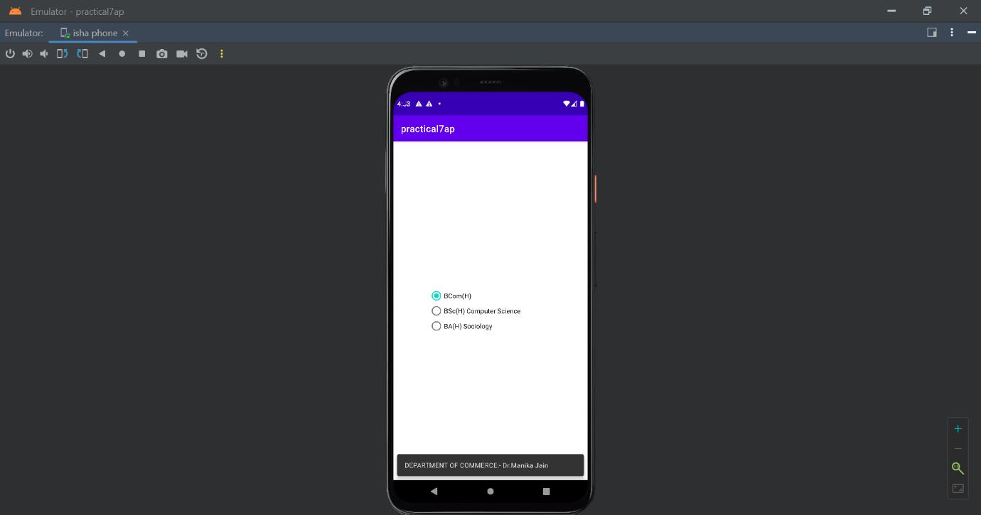

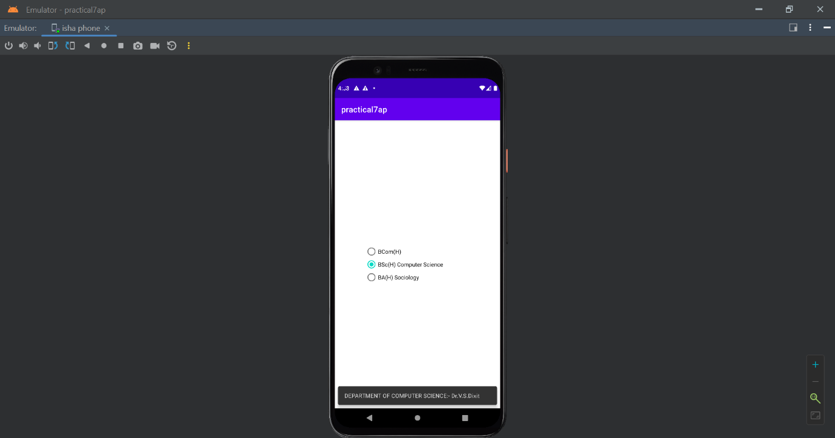

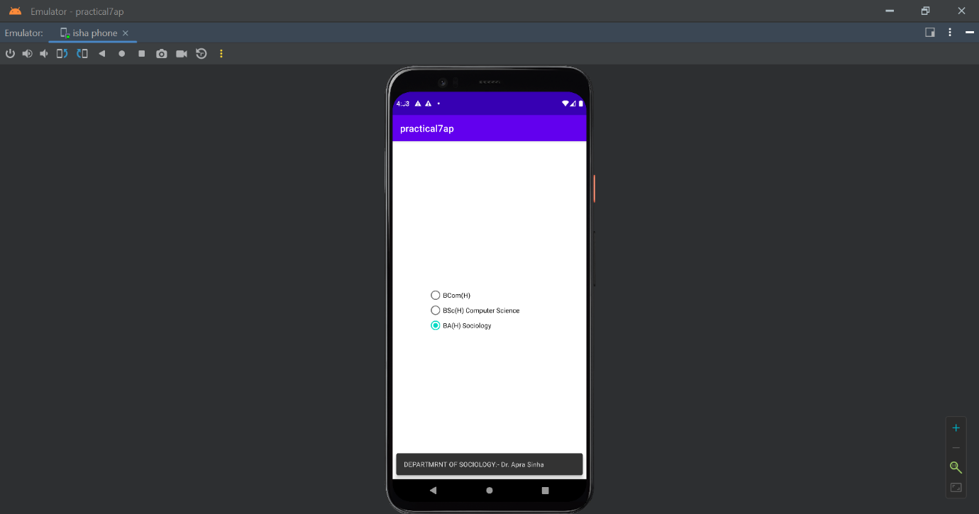

**PRACTICAL 9**

**OBJECTIVE:a) Create an application with three buttons (with different color names) vertically aligned, on selecting a button color of the screen will change.**

**Activity_main.xml**

<?xml version="1.0" encoding="utf-8"?>  
<androidx.constraintlayout.widget.ConstraintLayout xmlns:android="http://schemas.android.com/apk/res/android"  
 xmlns:app="http://schemas.android.com/apk/res-auto"  
 xmlns:tools="http://schemas.android.com/tools"  
 android:id="@+id/layoutSuperParent"  
 android:layout_width="match_parent"  
 android:layout_height="match_parent"  
 tools:context=".MainActivity">  
  
 <LinearLayout  
 android:id="@+id/linearLayout"  
 android:layout_width="wrap_content"  
 android:layout_height="wrap_content"  
 android:orientation="vertical"  
 app:layout_constraintBottom_toBottomOf="parent"  
 app:layout_constraintLeft_toLeftOf="parent"  
 app:layout_constraintRight_toRightOf="parent"  
 app:layout_constraintTop_toTopOf="parent">  
 <Button  
 android:layout_width="150dp"  
 android:layout_height="wrap_content"  
 android:id="@+id/btnRed"  
 android:layout_gravity="center"  
 android:backgroundTint="@android:color/holo_red_dark"  
 android:text="RED"/>  
 <Button  
 android:layout_width="150dp"  
 android:layout_height="wrap_content"  
 android:id="@+id/btnBlue"  
 android:layout_gravity="center"  
 android:backgroundTint="@android:color/holo_blue_light"  
 android:text="BLUE"/>  
 <Button  
 android:layout_width="150dp"  
 android:layout_height="wrap_content"  
 android:id="@+id/btnGreen"  
 android:gravity="center"  
 android:backgroundTint="@android:color/holo_green_dark"  
 android:text="GREEN"/>  
 <Button  
 android:layout_width="150dp"  
 android:layout_height="wrap_content"  
 android:id="@+id/btnReset"  
 android:gravity="center"  
 android:text="Reset"/>  
  
  
</LinearLayout>  
  
  
</androidx.constraintlayout.widget.ConstraintLayout>

**mainActivity.java**

package com.example.a9a;  
  
import androidx.appcompat.app.AppCompatActivity;  
  
import android.os.Bundle;  
import android.graphics.Color;  
import android.view.View;  
import android.widget.Button;  
import androidx.constraintlayout.widget.ConstraintLayout;  
  
public class MainActivity extends AppCompatActivity {  
 private Button btnRed;  
 private Button btnBlue;  
 private Button btnGreen;  
 private Button btnReset;  
 private ConstraintLayout layoutSuperParent;  
  
 @Override  
 protected void onCreate(Bundle savedInstanceState) {  
 super.onCreate(savedInstanceState);  
 setContentView(R.layout.*activity_main*);  
 layoutSuperParent=(ConstraintLayout)findViewById(R.id.*layoutSuperParent*);  
 btnRed=(Button)findViewById(R.id.*btnRed*);  
 btnBlue=(Button)findViewById(R.id.*btnBlue*);  
 btnGreen=(Button)findViewById(R.id.*btnGreen*);  
 btnReset=(Button)findViewById(R.id.*btnReset*);  
 btnRed.setOnClickListener(this::onClick);  
 btnBlue.setOnClickListener(this::onClick);  
 btnGreen.setOnClickListener(this::onClick);  
 btnReset.setOnClickListener(this::onClick);  
 }  
 public void onClick(View v){  
 switch (v.getId()){  
 case R.id.*btnRed*:  
 layoutSuperParent.setBackgroundColor(Color.*RED*);  
 break;  
 case R.id.*btnBlue*:  
 layoutSuperParent.setBackgroundColor(Color.*BLUE*);  
 break;  
 case R.id.*btnGreen*:  
 layoutSuperParent.setBackgroundColor(Color.*GREEN*);  
 break;  
 case R.id.*btnReset*:  
 layoutSuperParent.setBackgroundColor(Color.*TRANSPARENT*);  
 break;  
 default:  
 break;  
 }  
 }  
}

**OUTPUT**

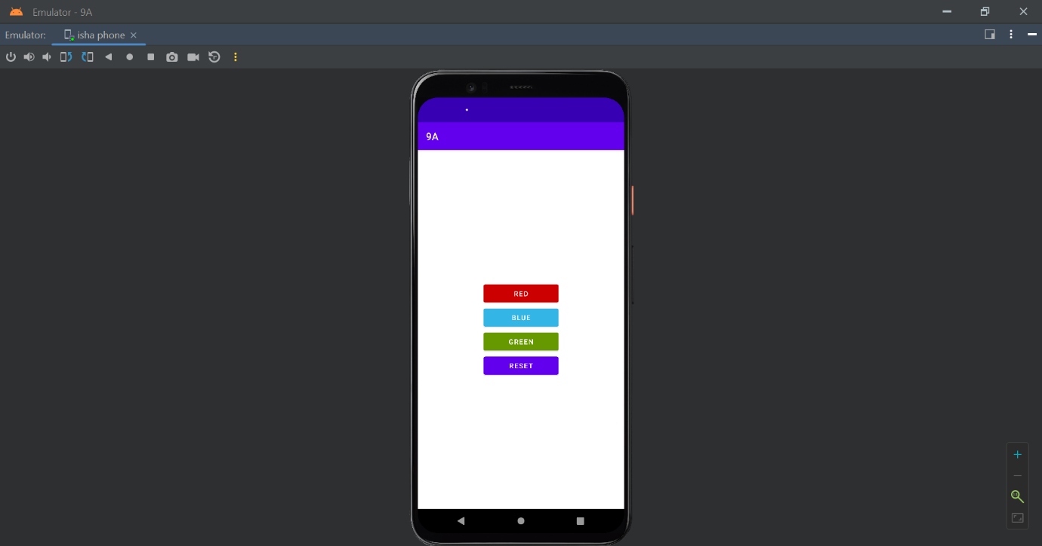

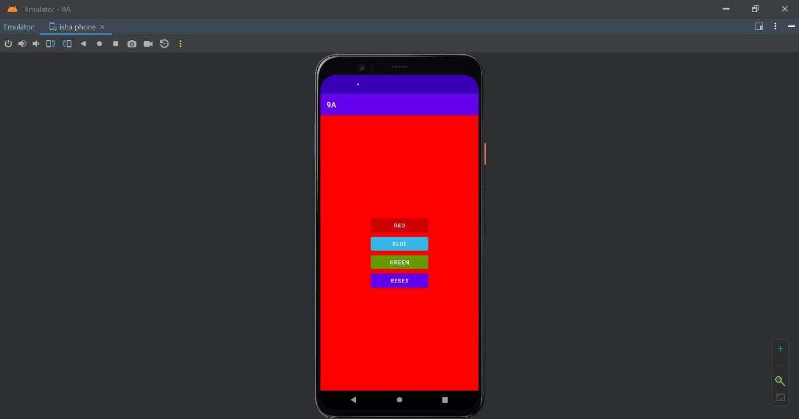

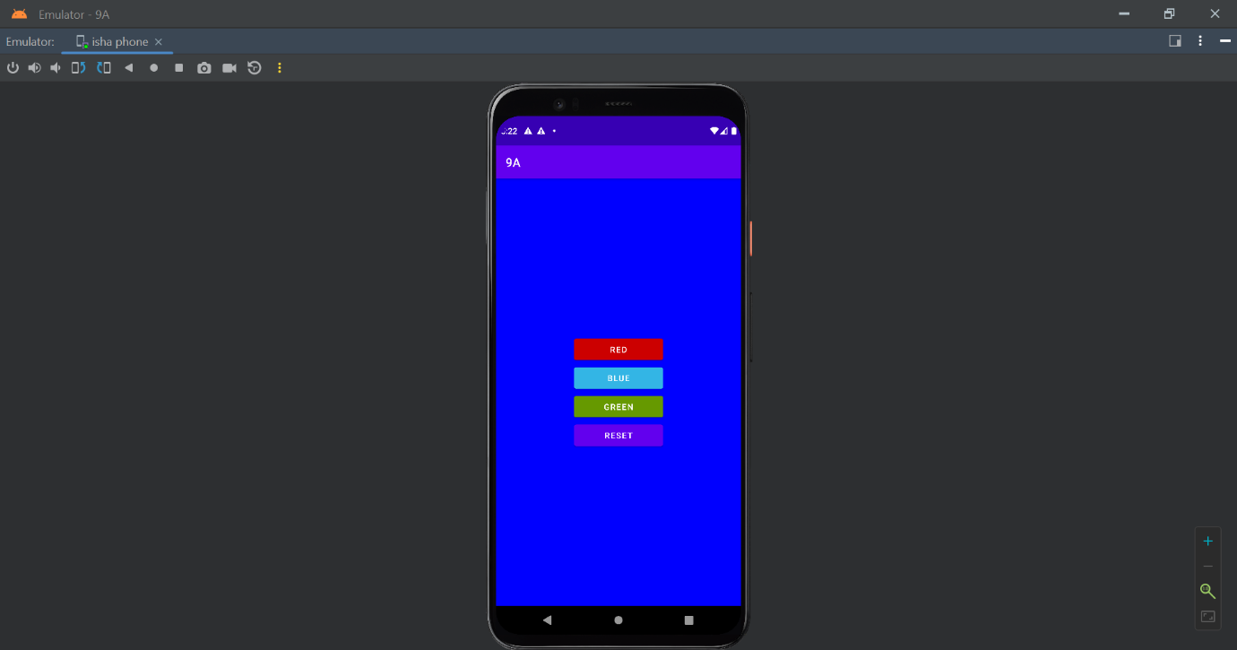

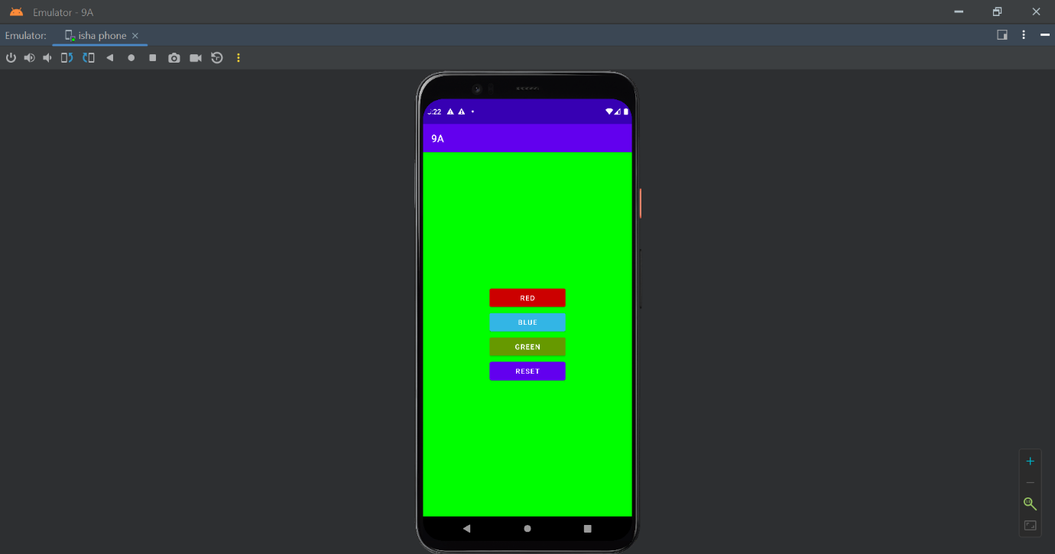

**b) Create an application with three buttons horizontally aligned, on selecting a button color of the screen will change.**

**Activity_main.java**

<?xml version="1.0" encoding="utf-8"?>  
<androidx.constraintlayout.widget.ConstraintLayout xmlns:android="http://schemas.android.com/apk/res/android"  
 xmlns:app="http://schemas.android.com/apk/res-auto"  
 xmlns:tools="http://schemas.android.com/tools"  
 android:id="@+id/layoutSuperParent"  
 android:layout_width="match_parent"  
 android:layout_height="match_parent"  
 tools:context=".MainActivity">  
  
 <LinearLayout  
 android:id="@+id/linearLayout"  
 android:layout_width="wrap_content"  
 android:layout_height="wrap_content"  
 android:orientation="vertical"  
 app:layout_constraintBottom_toBottomOf="parent"  
 app:layout_constraintEnd_toEndOf="parent"  
 app:layout_constraintHorizontal_bias="0.131"  
 app:layout_constraintLeft_toLeftOf="parent"  
 app:layout_constraintRight_toRightOf="parent"  
 app:layout_constraintStart_toStartOf="parent"  
 app:layout_constraintTop_toTopOf="parent"  
 app:layout_constraintVertical_bias="0.563">  
  
 </LinearLayout>  
  
 <Button  
 android:id="@+id/btnBlue"  
 android:layout_width="100dp"  
 android:layout_height="wrap_content"  
 android:layout_gravity="center"  
 android:backgroundTint="@android:color/holo_blue_light"  
 android:text="BLUE"  
 app:layout_constraintBottom_toBottomOf="parent"  
 app:layout_constraintEnd_toEndOf="parent"  
 app:layout_constraintHorizontal_bias="0.35"  
 app:layout_constraintStart_toStartOf="parent"  
 app:layout_constraintTop_toTopOf="parent"  
 app:layout_constraintVertical_bias="0.532" />  
  
 <Button  
 android:id="@+id/btnGreen"  
 android:layout_width="100dp"  
 android:layout_height="wrap_content"  
 android:backgroundTint="@android:color/holo_green_dark"  
 android:gravity="center"  
 android:text="GREEN"  
 app:layout_constraintBottom_toBottomOf="parent"  
 app:layout_constraintEnd_toEndOf="parent"  
 app:layout_constraintHorizontal_bias="0.028"  
 app:layout_constraintStart_toStartOf="parent"  
 app:layout_constraintTop_toTopOf="parent"  
 app:layout_constraintVertical_bias="0.532" />  
  
 <Button  
 android:id="@+id/btnRed"  
 android:layout_width="100dp"  
 android:layout_height="wrap_content"  
 android:layout_gravity="center"  
 android:backgroundTint="@android:color/holo_red_dark"  
 android:text="RED"  
 app:layout_constraintBottom_toBottomOf="parent"  
 app:layout_constraintEnd_toEndOf="parent"  
 app:layout_constraintHorizontal_bias="0.678"  
 app:layout_constraintStart_toStartOf="parent"  
 app:layout_constraintTop_toTopOf="parent"  
 app:layout_constraintVertical_bias="0.532" />  
  
 <Button  
 android:id="@+id/btnReset"  
 android:layout_width="100dp"  
 android:layout_height="wrap_content"  
 android:gravity="center"  
 android:text="Reset"  
 app:layout_constraintBottom_toBottomOf="parent"  
 app:layout_constraintEnd_toEndOf="parent"  
 app:layout_constraintHorizontal_bias="1.0"  
 app:layout_constraintStart_toStartOf="parent"  
 app:layout_constraintTop_toTopOf="parent"  
 app:layout_constraintVertical_bias="0.532" />  
  
</androidx.constraintlayout.widget.ConstraintLayout>

**mainActivity.java**

package com.example.a9a;  
  
import androidx.appcompat.app.AppCompatActivity;  
  
import android.os.Bundle;  
import android.graphics.Color;  
import android.view.View;  
import android.widget.Button;  
import androidx.constraintlayout.widget.ConstraintLayout;  
  
public class MainActivity extends AppCompatActivity {  
 private Button btnRed;  
 private Button btnBlue;  
 private Button btnGreen;  
 private Button btnReset;  
 private ConstraintLayout layoutSuperParent;  
  
 @Override  
 protected void onCreate(Bundle savedInstanceState) {  
 super.onCreate(savedInstanceState);  
 setContentView(R.layout.*activity_main*);  
 layoutSuperParent=(ConstraintLayout)findViewById(R.id.*layoutSuperParent*);  
 btnRed=(Button)findViewById(R.id.*btnRed*);  
 btnBlue=(Button)findViewById(R.id.*btnBlue*);  
 btnGreen=(Button)findViewById(R.id.*btnGreen*);  
 btnReset=(Button)findViewById(R.id.*btnReset*);  
 btnRed.setOnClickListener(this::onClick);  
 btnBlue.setOnClickListener(this::onClick);  
 btnGreen.setOnClickListener(this::onClick);  
 btnReset.setOnClickListener(this::onClick);  
 }  
 public void onClick(View v){  
 switch (v.getId()){  
 case R.id.*btnRed*:  
 layoutSuperParent.setBackgroundColor(Color.*RED*);  
 break;  
 case R.id.*btnBlue*:  
 layoutSuperParent.setBackgroundColor(Color.*BLUE*);  
 break;  
 case R.id.*btnGreen*:  
 layoutSuperParent.setBackgroundColor(Color.*GREEN*);  
 break;  
 case R.id.*btnReset*:  
 layoutSuperParent.setBackgroundColor(Color.*TRANSPARENT*);  
 break;  
 default:  
 break;  
 }  
 }  
}

**OUTPUT**

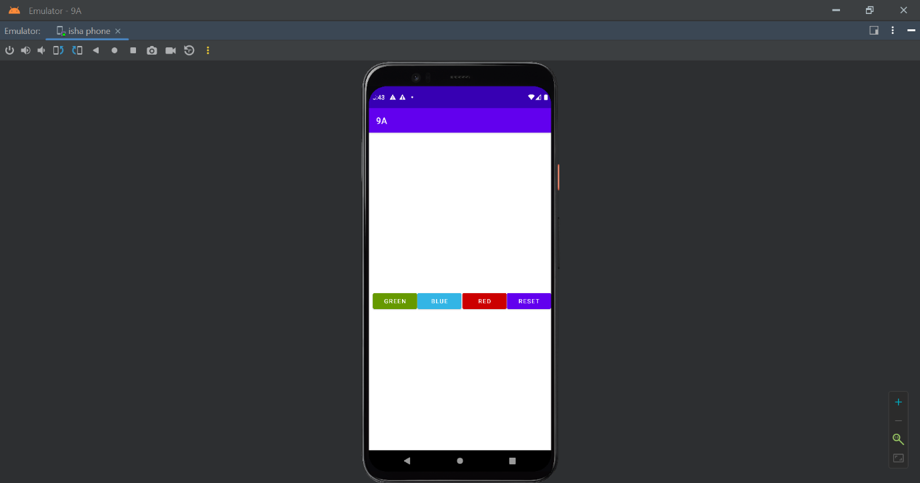

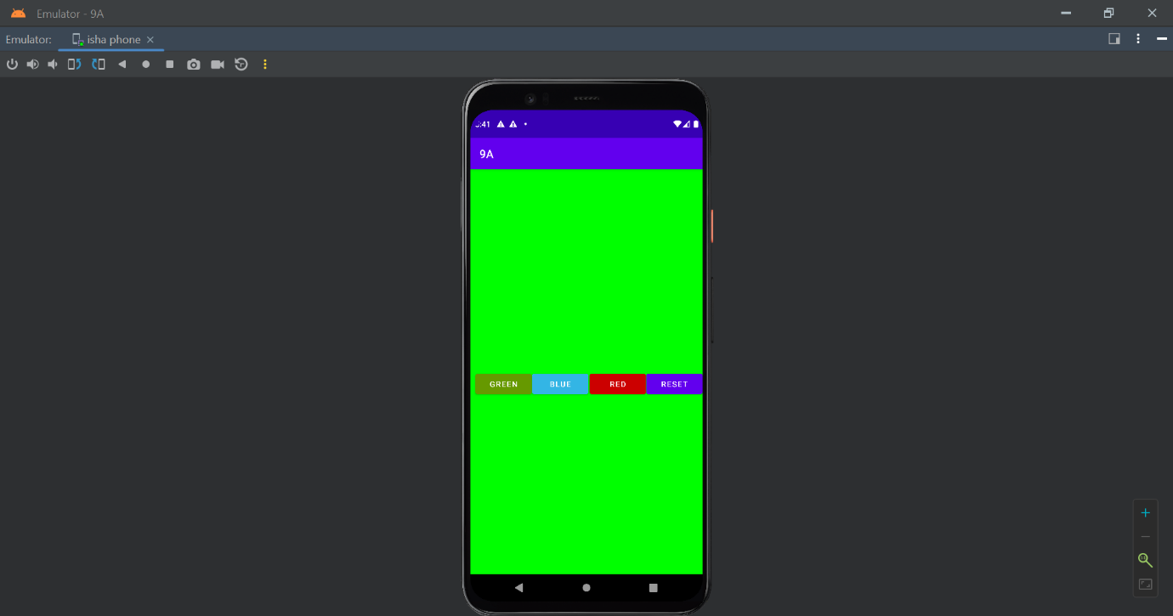

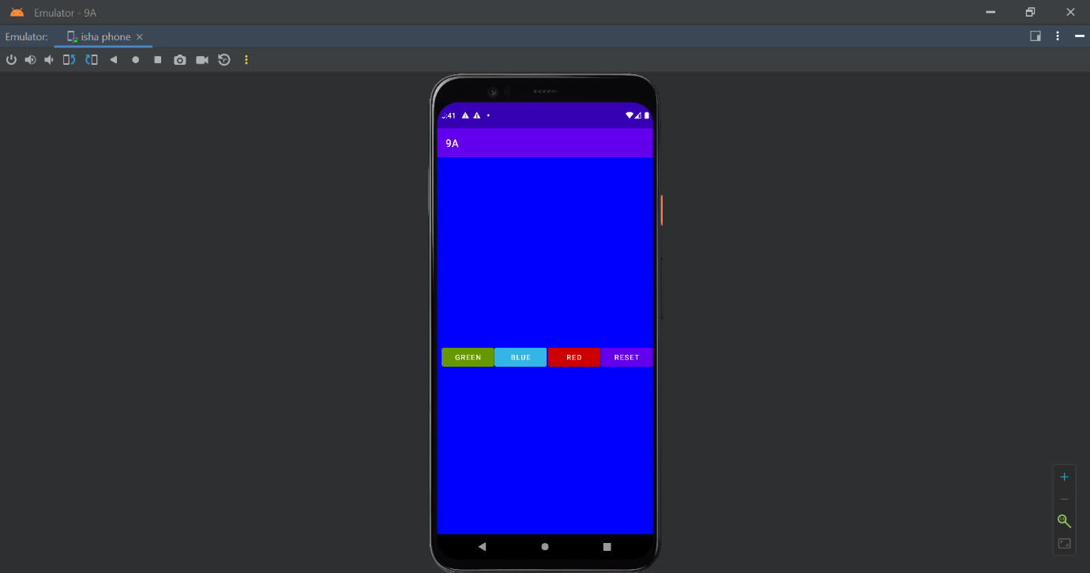

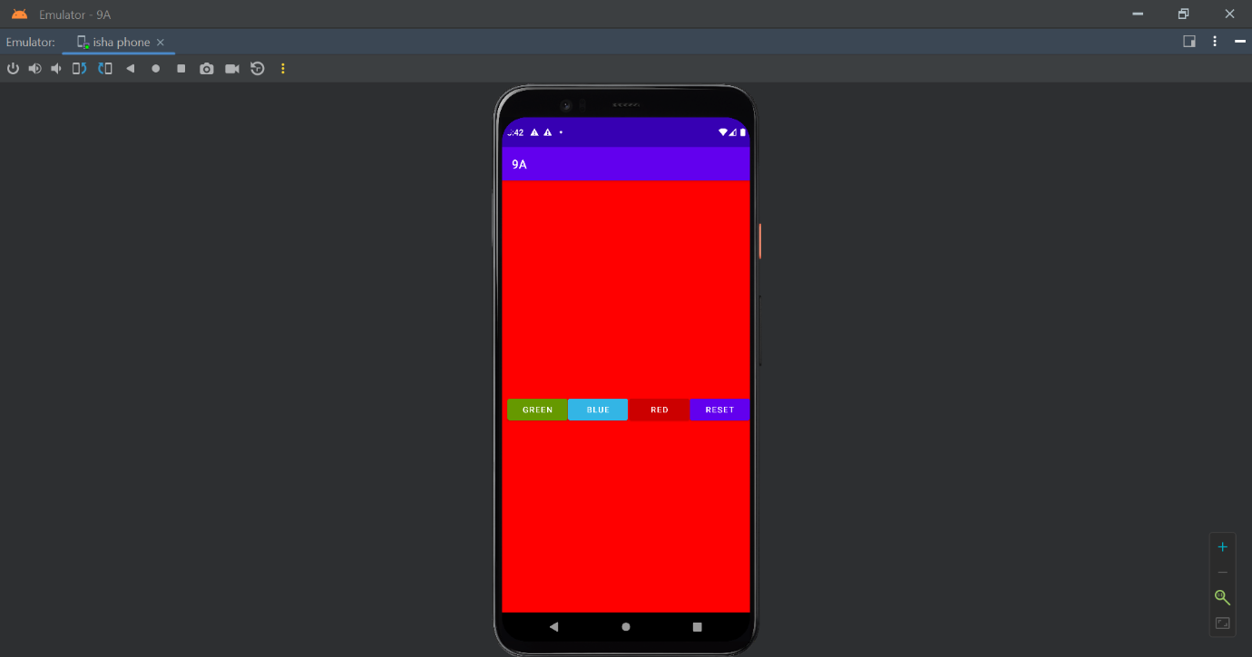

**PRACTICAL 10**

**OBJECTIVE:Create a Login application (check username and password). On successful login, pop up the message. ("Welcome username")**

**CODE**

app/src/main/res/layout/activity_main.xml

<?xml version="1.0" encoding="utf-8"?>  
<androidx.constraintlayout.widget.ConstraintLayout xmlns:android="http://schemas.android.com/apk/res/android"  
 xmlns:app="http://schemas.android.com/apk/res-auto"  
 xmlns:tools="http://schemas.android.com/tools"  
 android:layout_width="match_parent"  
 android:layout_height="match_parent"  
 tools:context=".MainActivity">  
  
 <EditText  
 android:id="@+id/etEmail"  
 android:layout_width="wrap_content"  
 android:layout_height="wrap_content"  
 android:layout_marginTop="240dp"  
 android:autofillHints="false"  
 android:ems="10"  
 android:hint="e_mail_id"  
 android:inputType="textEmailAddress"  
 app:layout_constraintBottom_toTopOf="@id/etPassword"  
 app:layout_constraintEnd_toEndOf="parent"  
 app:layout_constraintStart_toStartOf="parent"  
 app:layout_constraintTop_toTopOf="parent" />  
 <EditText  
 android:id="@+id/etPassword"  
 android:layout_width="wrap_content"  
 android:layout_height="wrap_content"  
 android:layout_marginTop="10dp"  
 android:autofillHints="false"  
 android:ems="10"  
 android:hint="password"  
 android:inputType="textPassword"  
 app:layout_constraintBottom_toTopOf="@id/btnLogin"  
 app:layout_constraintEnd_toEndOf="parent"  
 app:layout_constraintStart_toStartOf="parent"  
 app:layout_constraintTop_toBottomOf="@id/etEmail" />  
 <Button  
 android:id="@+id/btnLogin"  
 android:layout_width="wrap_content"  
 android:layout_height="wrap_content"  
 android:layout_marginTop="30dp"  
 android:text="login"  
 app:layout_constraintBottom_toTopOf="@id/btnRegister"  
 app:layout_constraintEnd_toEndOf="parent"  
 app:layout_constraintStart_toStartOf="parent"  
 app:layout_constraintTop_toBottomOf="@id/etPassword" />  
 <Button  
 android:id="@+id/btnRegister"  
 android:layout_width="wrap_content"  
 android:layout_height="wrap_content"  
 android:layout_marginBottom="250dp"  
 android:text="register"  
 app:layout_constraintBottom_toBottomOf="parent"  
 app:layout_constraintEnd_toEndOf="parent"  
 app:layout_constraintStart_toStartOf="parent"  
 app:layout_constraintTop_toBottomOf="@id/btnLogin" />  
  
</androidx.constraintlayout.widget.ConstraintLayout>

app/src/main/res/values/strings.xml

<resources>  
 <string name="app_name">LoginValidation</string>  
 <string name="welcome">Welcome</string>  
 <string name="log_out">Log Out</string>  
 <string name="password">Password</string>  
 <string name="e_mail_id">E-mail ID</string>  
 <string name="login">Login</string>  
 <string name="register">Register</string>  
 <string name="cancel">Cancel</string>  
 <string name="ok">Ok</string>  
</resources>

app/src/main/java/com/example/loginvalidation/MainActivity.java

package com.example.loginvalidation;  
import android.database.sqlite.SQLiteConstraintException;  
import android.os.Bundle;  
import android.util.Log;  
import android.widget.Button;  
import android.widget.EditText;  
import android.widget.Toast;  
import androidx.appcompat.app.AppCompatActivity;  
import com.example.loginvalidation.models.User;  
import com.example.loginvalidation.services.UserService;  
public class MainActivity extends AppCompatActivity {  
 private EditText etEmail;  
 private EditText etPassword;  
 private Button btnLogin;  
 private Button btnRegister;  
 private UserService userService;  
 @Override  
 protected void onCreate(Bundle savedInstanceState) {  
 super.onCreate(savedInstanceState);  
 setContentView(R.layout.*activity_main*);  
 userService = UserService.*getInstance*();  
 UserService.*initDatabase*(this);  
 etEmail = (EditText) findViewById(R.id.*etEmail*);  
 etPassword = (EditText) findViewById(R.id.*etPassword*);  
 btnLogin = (Button) findViewById(R.id.*btnLogin*);  
 btnRegister = (Button) findViewById(R.id.*btnRegister*);  
 btnLogin.setOnClickListener(v -> {  
 User user = validateCredentials();  
 if (user != null) {  
 try {  
 userService.login(user);  
 Toast.*makeText*(this, "Welcome " + userService.getUser().email, Toast.*LENGTH_SHORT*).show();  
 } catch (IllegalStateException illegalStateException) {  
 Toast.*makeText*(this, "Invalid Email/Password", Toast.*LENGTH_SHORT*).show();  
 } catch (Exception e) {  
 Log.*d*("TAG", e.getMessage());  
 Toast.*makeText*(this, "Error", Toast.*LENGTH_SHORT*).show();  
 }  
 }  
 });  
 btnRegister.setOnClickListener(v -> { User user = validateCredentials(); if (user != null) {  
 try {  
 userService.register(user);  
 Toast.*makeText*(this, "Registered", Toast.*LENGTH_SHORT*).show();  
 } catch (SQLiteConstraintException sqLiteConstraintException)  
 {  
 Toast.*makeText*(this, "Email Already Used", Toast.*LENGTH_SHORT*).show();  
 } catch (Exception e) {  
 Toast.*makeText*(this, "Error", Toast.*LENGTH_SHORT*).show();  
 }  
 }  
 });  
 }  
 private User validateCredentials() {  
 String email = etEmail.getText().toString().trim();  
 String password = etPassword.getText().toString().trim();  
 if (email.length() == 0) {  
 etEmail.setError("Enter your e-mail address");  
 return null;  
 }  
 if (password.length() == 0) {  
 etPassword.setError("Enter your password");  
 return null;  
 }  
 return new User(email, password);  
 }  
}

app/src/main/java/com/example/loginvalidation/models/User.java

package com.example.loginvalidation.models;  
import androidx.annotation.NonNull;  
import androidx.room.ColumnInfo;  
import androidx.room.Entity;  
import androidx.room.PrimaryKey;  
@Entity  
public class User {  
 @PrimaryKey  
 @NonNull  
 @ColumnInfo(name = "email")  
 public String email;  
 @NonNull  
 @ColumnInfo(name = "password")  
 public String password;  
 public User(@NonNull String email, @NonNull String password) {  
 this.email = email;  
 this.password = password;  
 }  
}

app/src/main/java/com/example/loginvalidation/data/UserDao.java

package com.example.loginvalidation.data;  
import androidx.room.Dao;  
import androidx.room.Delete;  
import androidx.room.Insert;  
import androidx.room.Query;  
import java.util.List;  
import  
 com.example.loginvalidation.models.User;  
@Dao  
public interface UserDao {  
 @Query("SELECT * FROM user")  
 List<User> getAll();  
 @Query("SELECT * FROM user WHERE email LIKE :email LIMIT 1")  
 User findByEmail(String email);  
 @Insert  
 void insert(User user);  
 @Delete  
 void delete(User user);  
}

app/src/main/java/com/example/loginvalidation/data/UserDatabase.java

package com.example.loginvalidation.data;  
import androidx.room.RoomDatabase;  
import androidx.room.Database;  
import com.example.loginvalidation.models.User;  
@Database(entities = {User.class}, version = 1)  
public abstract class UserDatabase extends RoomDatabase {  
 public abstract UserDao userDao();  
}

app/src/main/java/com/example/loginvalidation/services/UserService.java

package com.example.loginvalidation.data;  
import androidx.room.RoomDatabase;  
import androidx.room.Database;  
import com.example.loginvalidation.models.User;  
@Database(entities = {User.class}, version = 1)  
public abstract class UserDatabase extends RoomDatabase {  
 public abstract UserDao userDao();  
}

**OUTPUT**

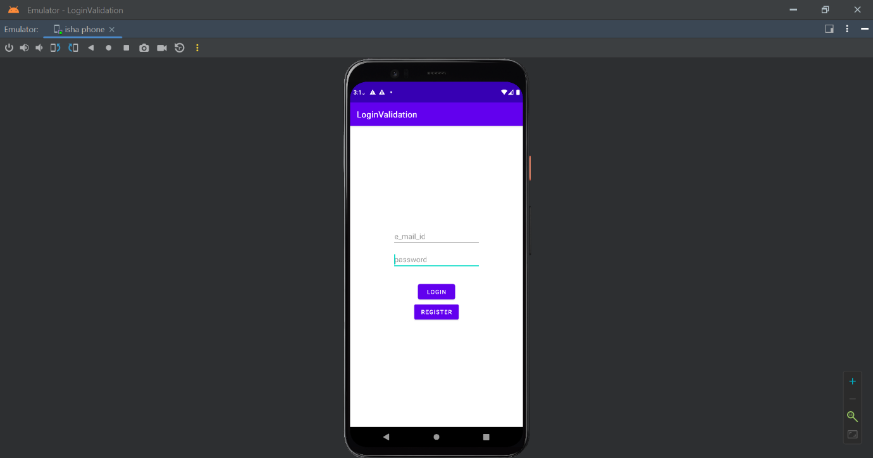

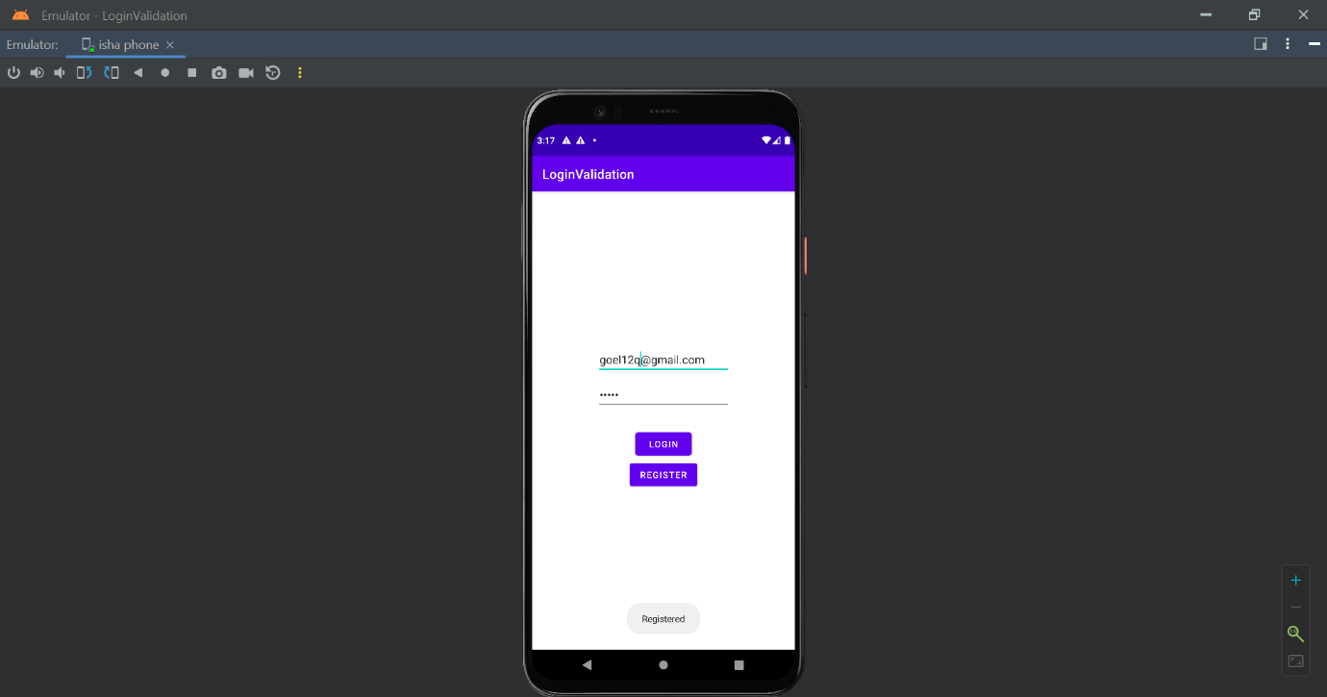

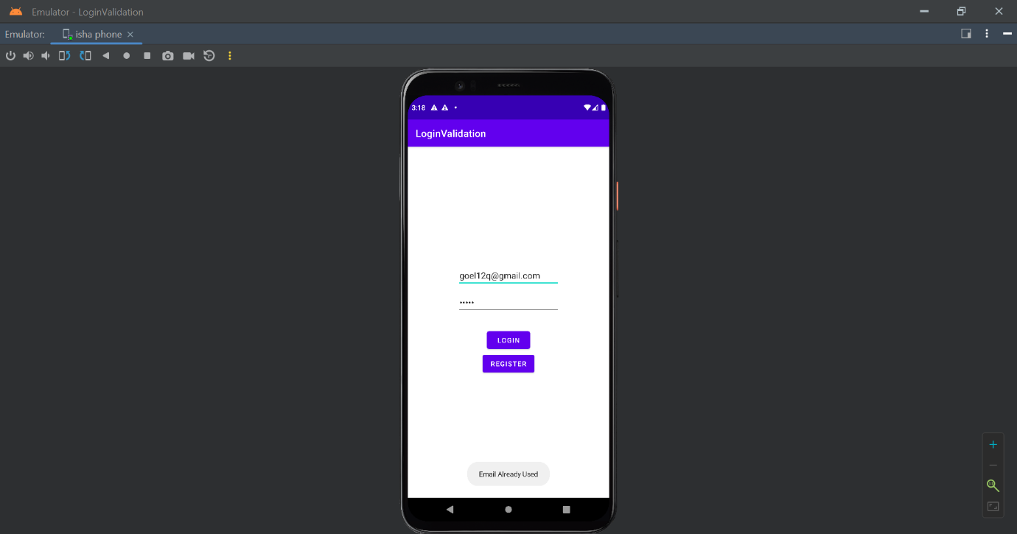

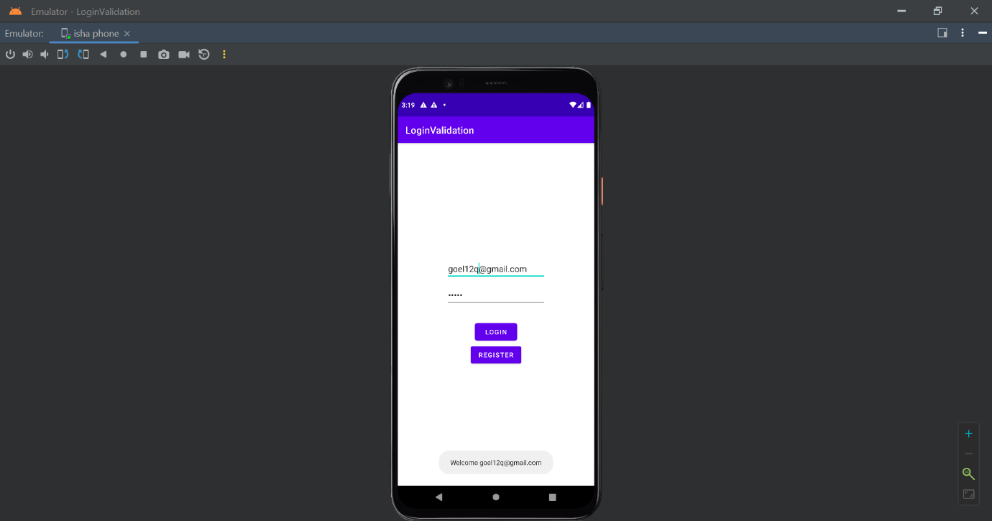

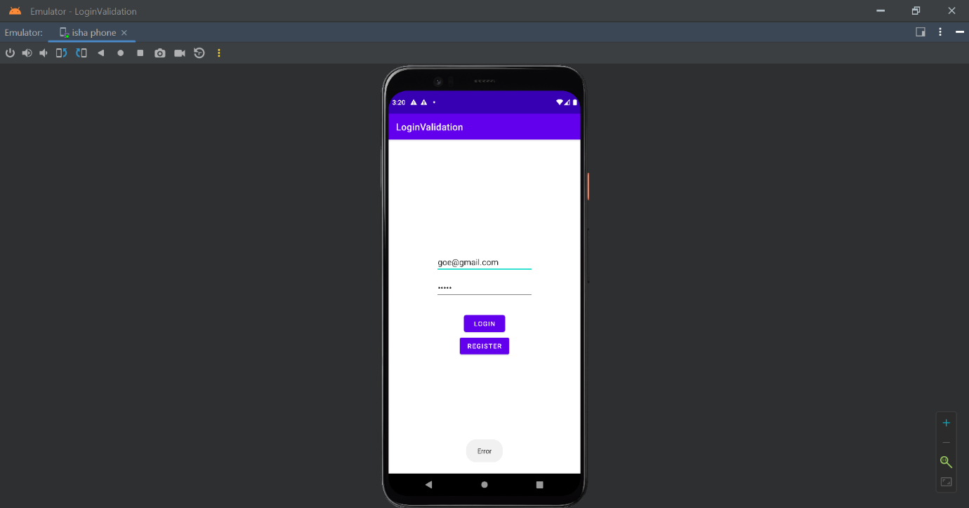

**PRACTICAL 11**

**OBJECTIVE: Create a login application as above, on successful login redirect to another activity with a logout button. On click of the logout button, a dialog appears with OK and CANCEL buttons. On OK button click to go to login activity and on CANCEL stay at the same activity.**

app/src/main/AndroidManifest.xml

<?xml version="1.0" encoding="utf-8"?>  
<manifest xmlns:android="http://schemas.android.com/apk/res/android"  
 package="com.example.loginmodule">  
 <application  
 android:allowBackup="true"  
 android:icon="@mipmap/ic_launcher"  
 android:label="@string/app_name"  
 android:roundIcon="@mipmap/ic_launcher_round"  
 android:supportsRtl="true"  
 android:theme="@style/Theme.LoginModule">  
 <activity android:name=".MemberModule"></activity>  
 <activity android:name=".MainActivity"  
 android:exported="true">  
 <intent-filter>  
 <action android:name="android.intent.action.MAIN" />  
 <category android:name="android.intent.category.LAUNCHER" />  
 </intent-filter>  
 </activity>  
 </application>  
</manifest>

app/src/main/res/layout/activity_main.xml

<?xml version="1.0" encoding="utf-8"?>  
<androidx.constraintlayout.widget.ConstraintLayout xmlns:android="http://schemas.android.com/apk/res/android"  
 xmlns:app="http://schemas.android.com/apk/res-auto"  
 xmlns:tools="http://schemas.android.com/tools"  
 android:layout_width="match_parent"  
 android:layout_height="match_parent"  
 tools:context=".MainActivity">  
 <EditText  
 android:id="@+id/etEmail"  
 android:layout_width="wrap_content"  
 android:layout_height="wrap_content"  
 android:layout_marginTop="240dp"  
 android:autofillHints="false"  
 android:ems="10"  
 android:hint="e_mail_id"  
 android:inputType="textEmailAddress"  
 app:layout_constraintBottom_toTopOf="@id/etPassword"  
 app:layout_constraintEnd_toEndOf="parent"  
 app:layout_constraintStart_toStartOf="parent"  
 app:layout_constraintTop_toTopOf="parent" />  
 <EditText  
 android:id="@+id/etPassword"  
 android:layout_width="wrap_content"  
 android:layout_height="wrap_content"  
 android:layout_marginTop="10dp"  
 android:autofillHints="false"  
 android:ems="10"  
 android:hint="password"  
 android:inputType="textPassword"  
 app:layout_constraintBottom_toTopOf="@id/btnLogin"  
 app:layout_constraintEnd_toEndOf="parent"  
 app:layout_constraintStart_toStartOf="parent"  
 app:layout_constraintTop_toBottomOf="@id/etEmail" />  
 <Button  
 android:id="@+id/btnLogin"  
 android:layout_width="wrap_content"  
 android:layout_height="wrap_content"  
 android:layout_marginTop="30dp"  
 android:text="login"  
 app:layout_constraintBottom_toTopOf="@id/btnRegister"  
 app:layout_constraintEnd_toEndOf="parent"  
 app:layout_constraintStart_toStartOf="parent"  
 app:layout_constraintTop_toBottomOf="@id/etPassword" />  
 <Button  
 android:id="@+id/btnRegister"  
 android:layout_width="wrap_content"  
 android:layout_height="wrap_content"  
 android:layout_marginBottom="250dp"  
 android:text="register"  
 app:layout_constraintBottom_toBottomOf="parent"  
 app:layout_constraintEnd_toEndOf="parent"  
 app:layout_constraintStart_toStartOf="parent"  
 app:layout_constraintTop_toBottomOf="@id/btnLogin" />  
  
</androidx.constraintlayout.widget.ConstraintLayout>

app/src/main/res/layout/activity_member_module.xml

<?xml version="1.0" encoding="utf-8"?>  
<androidx.constraintlayout.widget.ConstraintLayout xmlns:android="http://schemas.android.com/apk/res/android"  
 xmlns:app="http://schemas.android.com/apk/res-auto"  
 xmlns:tools="http://schemas.android.com/tools"  
 android:layout_width="match_parent"  
 android:layout_height="match_parent"  
 tools:context=".MemberModule">  
 <TextView  
 android:id="@+id/tvWelcome"  
 android:layout_width="wrap_content"  
 android:layout_height="wrap_content"  
 android:text="welcome"  
 android:textAppearance="@style/TextAppearance.AppCompat.Display1"  
 app:layout_constraintBottom_toTopOf="@id/tvEmail"  
 app:layout_constraintEnd_toEndOf="parent"  
 app:layout_constraintStart_toStartOf="parent"  
 app:layout_constraintTop_toTopOf="parent" />  
 <TextView  
 android:id="@+id/tvEmail"  
 android:layout_width="wrap_content"  
 android:layout_height="wrap_content"  
 android:text=""  
 app:layout_constraintBottom_toTopOf="@id/btnLogout"  
 app:layout_constraintEnd_toEndOf="parent"  
 app:layout_constraintStart_toStartOf="parent"  
 app:layout_constraintTop_toBottomOf="@id/tvWelcome" />  
 <Button  
 android:id="@+id/btnLogout"  
 android:layout_width="wrap_content"  
 android:layout_height="wrap_content"  
 android:text="log_out"  
 app:layout_constraintBottom_toBottomOf="parent"  
 app:layout_constraintEnd_toEndOf="parent"  
 app:layout_constraintStart_toStartOf="parent"  
 app:layout_constraintTop_toBottomOf="@+id/tvEmail" />  
</androidx.constraintlayout.widget.ConstraintLayout>

app/src/main/res/values/strings.xml

<resources>  
 <string name="app_name">LoginModule2</string>  
 <string name="welcome">Welcome</string>  
 <string name="log_out">Log Out</string>  
 <string name="password">Password</string>  
 <string name="e_mail_id">E-mail ID</string>  
 <string name="login">Login</string>  
 <string name="register">Register</string>  
 <string name="cancel">Cancel</string>  
 <string name="ok">OK</string>  
</resources>

app/src/main/java/com/example/loginmodule/MainActivity.java

package com.example.loginmodule;  
  
import androidx.appcompat.app.AppCompatActivity;  
  
import android.content.Intent;  
import android.database.sqlite.SQLiteConstraintException;  
import android.os.Bundle;  
import android.util.Log;  
import android.widget.Button;  
import android.widget.EditText;  
import android.widget.Toast;  
import com.example.loginmodule.models.User;  
import com.example.loginmodule.services.UserService;  
  
public class MainActivity extends AppCompatActivity {  
 private EditText etEmail;  
 private EditText etPassword;  
 private Button btnLogin;  
 private Button btnRegister;  
 private UserService userService;  
 @Override  
 protected void onCreate(Bundle savedInstanceState) {  
 super.onCreate(savedInstanceState);  
 setContentView(R.layout.*activity_main*);  
 userService = UserService.*getInstance*();  
 UserService.*initDatabase*(this);  
 etEmail = (EditText) findViewById(R.id.*etEmail*);  
 etPassword = (EditText) findViewById(R.id.*etPassword*);  
 btnLogin = (Button) findViewById(R.id.*btnLogin*);  
 btnRegister = (Button) findViewById(R.id.*btnRegister*);  
 btnLogin.setOnClickListener(v -> {  
 User user = validateCredentials();  
 if (user != null){  
 try {  
 userService.login(user);  
 Toast.*makeText*(this, "Logged In", Toast.*LENGTH_SHORT*).show();  
 startActivity(new Intent(this, MemberModule.class));  
 } catch (IllegalStateException illegalStateException) { Toast.*makeText*(this,  
 "Invalid E- mail/Password", Toast.*LENGTH_SHORT*).show();  
 } catch (Exception e) {  
 Log.*d*("TAG", e.getMessage());  
 Toast.*makeText*(this, "Error", Toast.*LENGTH_SHORT*).show();}  
 }  
 }); btnRegister.setOnClickListener(v -> { User  
 user = validateCredentials(); if (user !=  
 null) {  
 try {  
 userService.register(user);  
 Toast.*makeText*(this, "Registered", Toast.*LENGTH_SHORT*).show();  
 startActivity(new Intent(this, MemberModule.class));  
 } catch (SQLiteConstraintException sqLiteConstraintException)  
 {  
 Toast.*makeText*(this, "E-mail Already Used",  
 Toast.*LENGTH_SHORT*).show();  
 } catch (Exception e) {  
 Toast.*makeText*(this, "Error", Toast.*LENGTH_SHORT*).show();  
 }  
 }  
 });  
 }  
 private User validateCredentials() {  
 String email = etEmail.getText().toString().trim();  
 String password = etPassword.getText().toString().trim();  
 if (email.length() == 0) {  
 etEmail.setError("Enter your e-mail address");  
 return null;  
 }  
 if (password.length() == 0) {  
 etPassword.setError("Enter your password");  
 return null;  
 }  
 return new User(email, password);  
 }  
}

app/src/main/java/com/example/loginmodule/MemberModule.java

package com.example.loginmodule;  
import android.app.AlertDialog;  
import android.os.Bundle;  
import android.widget.TextView;  
import android.widget.Toast;  
import androidx.appcompat.app.AppCompatActivity;  
import com.example.loginmodule.models.User;  
import com.example.loginmodule.services.UserService;  
public class MemberModule extends AppCompatActivity {  
 private User user;  
 private UserService userService;  
 private TextView tvEmail;  
 private TextView btnLogout;  
 @Override  
 protected void onCreate(Bundle savedInstanceState) {  
 super.onCreate(savedInstanceState);  
 setContentView(R.layout.*activity_member_module*);  
 userService = UserService.*getInstance*();  
 user = userService.getUser();  
 tvEmail = (TextView) findViewById(R.id.*tvEmail*);  
 btnLogout = (TextView) findViewById(R.id.*btnLogout*);  
 if (user == null) {  
 super.finish();  
 } else {  
 tvEmail.setText(user.email);  
 }  
 btnLogout.setOnClickListener(v -> {  
 new AlertDialog.Builder(this)  
 .setTitle("Logout")  
 .setMessage("Are you sure you want to log out?")  
 .setPositiveButton(android.R.string.*ok*, (dialog, which) -> logoutUser()).setNegativeButton(android.R.string.*cancel*, null)  
 .setIcon(android.R.drawable.*ic_dialog_alert*)  
 .show();  
 });  
 }  
 private void logoutUser() {  
 userService.logout();  
 Toast.*makeText*(this, "Logged Out", Toast.*LENGTH_SHORT*).show();  
 super.finish();  
 }  
}

app/src/main/java/com/example/loginmodule/models/User.java

package com.example.loginmodule.models;  
import androidx.annotation.NonNull;  
import androidx.room.ColumnInfo;  
import androidx.room.Entity;  
import androidx.room.PrimaryKey;  
@Entity  
public class User {  
 @PrimaryKey  
 @NonNull  
 @ColumnInfo(name = "email")  
 public String email;  
 @NonNull  
 @ColumnInfo(name = "password")  
 public String password;  
 public User(@NonNull String email, @NonNull String password) {  
 this.email = email;  
 this.password = password;  
 }  
}

app/src/main/java/com/example/loginmodule/data/UserDao.java

package com.example.loginmodule.data;  
  
import androidx.room.Dao;  
import androidx.room.Delete;  
import androidx.room.Insert;  
import androidx.room.Query;  
  
import com.example.loginmodule.models.User;  
  
import java.util.List;  
@Dao  
public interface UserDao {  
 @Query("SELECT * FROM user")  
 List<User> getAll();  
 @Query("SELECT * FROM user WHERE email LIKE :email LIMIT 1")  
 User findByEmail(String email);  
 @Insert  
 void insert(User user);  
 @Delete  
 void delete(User user);  
}

app/src/main/java/com/example/loginmodule/data/UserDatabase.java

package com.example.loginmodule.data;  
import androidx.room.RoomDatabase;  
import androidx.room.Database;  
import com.example.loginmodule.models.User;  
@Database(entities = {User.class}, version = 1)  
public abstract class UserDatabase extends RoomDatabase {  
 public abstract UserDao userDao();  
}

app/src/main/java/com/example/loginmodule/services/UserService.

java

package com.example.loginmodule.services;  
import android.content.Context;  
import androidx.room.Room;  
import com.example.loginmodule.data.UserDatabase;  
import com.example.loginmodule.models.User;  
public class UserService {  
 private User user = null;  
 private static UserService *instance* = null;  
 private static UserDatabase *database* = null;  
 public void login(User user) throws IllegalStateException {  
 User u = *database*.userDao().findByEmail(user.email);  
 if (!u.password.equals(user.password))  
 throw new IllegalStateException("Password Mismatch");  
 this.user = user;  
 }  
 public void register(User user) {  
 *database*.userDao().insert(user);  
 this.user = user;  
 }  
 public void logout() {  
 this.user = null;  
 }  
 public User getUser() {  
 return user;  
 }  
 public static UserService getInstance() {  
 if (*instance* == null) {  
 *instance* = new UserService();  
 }  
 return *instance*;  
 }  
 public static void initDatabase(Context ctx) {  
 if (*database* == null) {  
 *database* = Room  
 .*databaseBuilder*(ctx, UserDatabase.class, "login_module")  
 .allowMainThreadQueries()  
 .build();  
 }  
 }  
}

**OUTPUT**

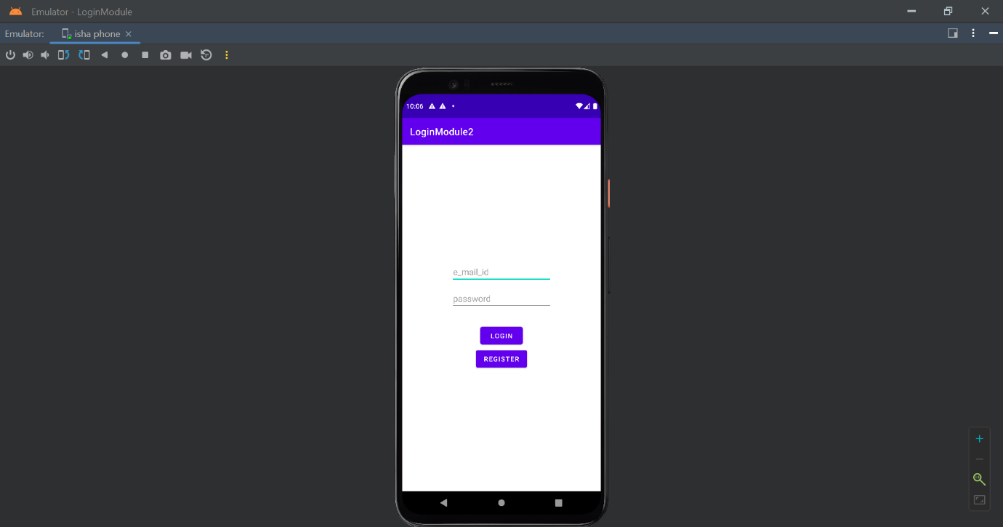

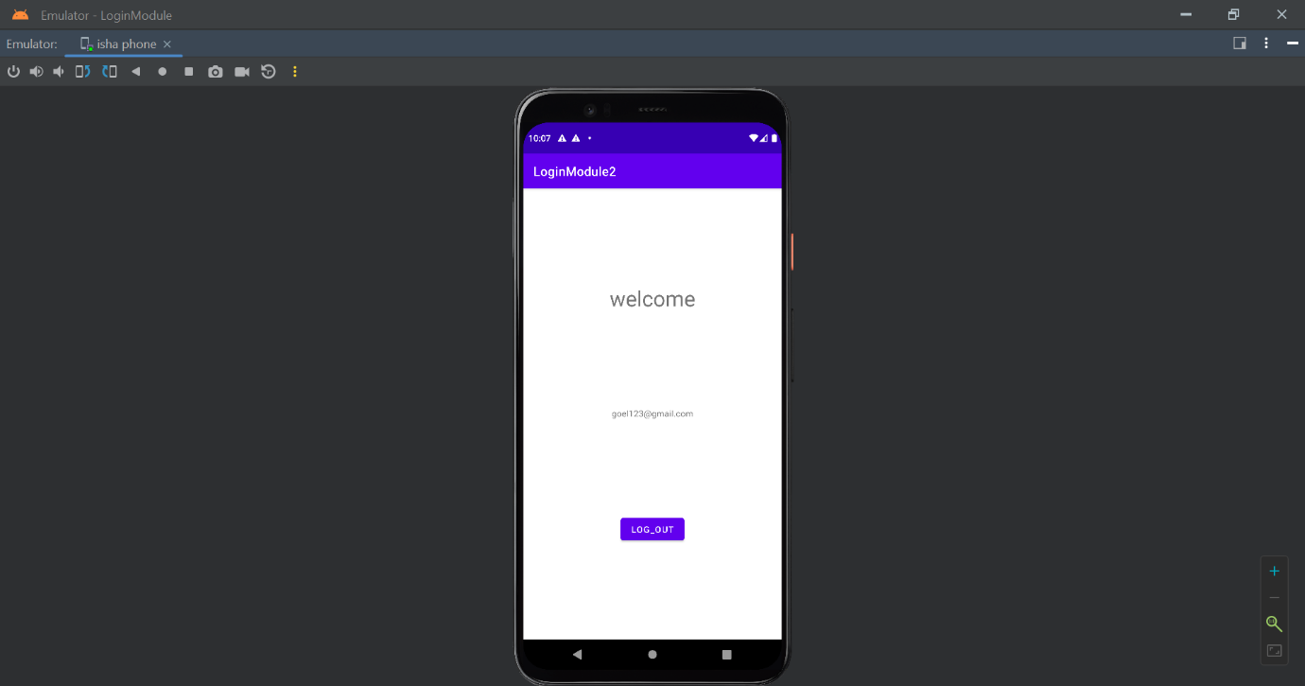

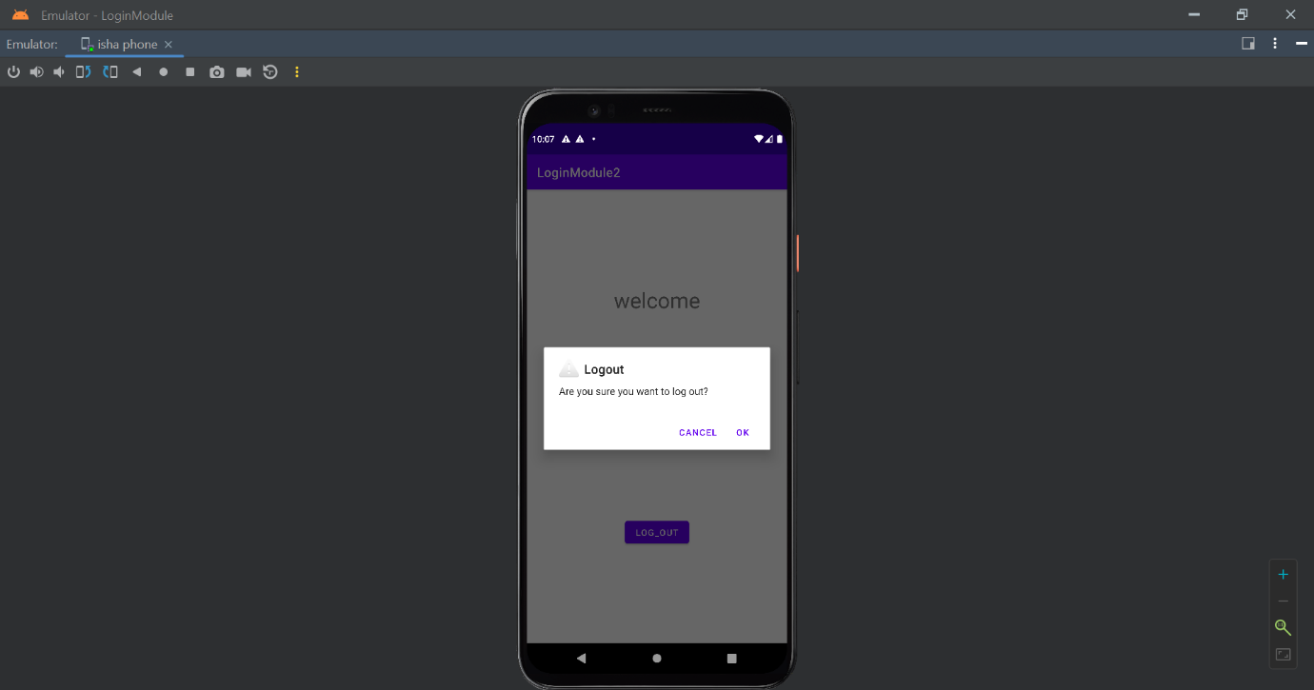

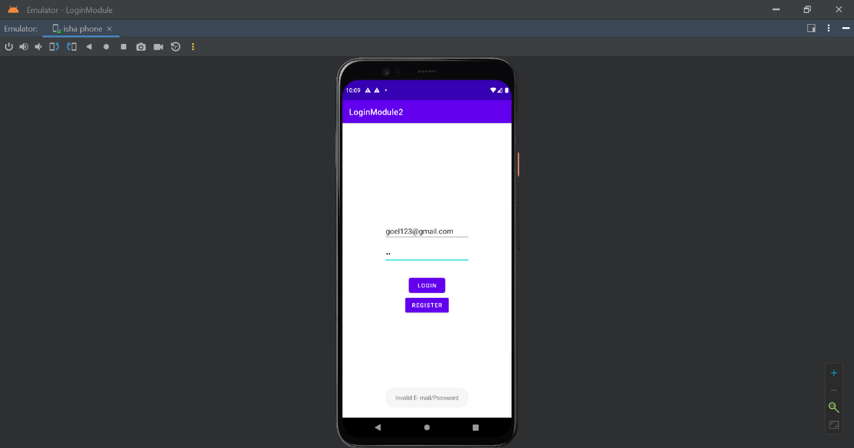

**PRACTICAL 12**

**OBJECTIVE: Create an application to Create, Insert, Update, and Delete operations on the database.**

**CODE**

**activity_main.xml**

<?xml version="1.0" encoding="utf-8"?>  
<androidx.constraintlayout.widget.ConstraintLayout xmlns:android="http://schemas.android.com/apk/res/android"  
 xmlns:app="http://schemas.android.com/apk/res-auto"  
 xmlns:tools="http://schemas.android.com/tools"  
 android:layout_width="match_parent"  
 android:layout_height="match_parent"  
 tools:context=".MainActivity">  
  
 <TextView  
 android:id="@+id/textView"  
 android:layout_width="345dp"  
 android:layout_height="99dp"  
 android:layout_marginTop="36dp"  
 android:gravity="center"  
 android:text="Enter Your Details"  
 android:textSize="30dp"  
 app:layout_constraintEnd_toEndOf="parent"  
 app:layout_constraintStart_toStartOf="parent"  
 app:layout_constraintTop_toTopOf="parent" />  
 <EditText  
 android:id="@+id/name"  
 android:layout_width="wrap_content"  
 android:layout_height="wrap_content"  
 android:ems="10"  
 android:inputType="textPersonName"  
 android:text="Name"  
 app:layout_constraintBottom_toTopOf="@+id/age"  
 app:layout_constraintTop_toBottomOf="@+id/textView"  
 app:layout_constraintVertical_bias="0.635"  
 tools:layout_editor_absoluteX="99dp" />  
 <EditText  
 android:id="@+id/age"  
 android:layout_width="wrap_content"  
 android:layout_height="wrap_content"  
 android:ems="10"  
 android:inputType="textPersonName"  
 android:text="Age"  
 app:layout_constraintBottom_toBottomOf="parent"  
 app:layout_constraintTop_toTopOf="parent"  
 app:layout_constraintVertical_bias="0.37"  
 tools:layout_editor_absoluteX="99dp" />  
 <Button  
 android:id="@+id/insert"  
 android:layout_width="wrap_content"  
 android:layout_height="wrap_content"  
 android:text="INSERT"  
 app:layout_constraintBottom_toBottomOf="parent"  
 app:layout_constraintTop_toTopOf="parent"  
 app:layout_constraintVertical_bias="0.604"  
 tools:layout_editor_absoluteX="161dp" />  
 <Button  
 android:id="@+id/update"  
 android:layout_width="wrap_content"  
 android:layout_height="wrap_content"  
 android:text="UPDATE"  
 app:layout_constraintBottom_toBottomOf="parent"  
 app:layout_constraintTop_toTopOf="parent"  
 app:layout_constraintVertical_bias="0.715"  
 tools:layout_editor_absoluteX="161dp" />  
 <Button  
 android:id="@+id/delete"  
 android:layout_width="wrap_content"  
 android:layout_height="wrap_content"  
 android:layout_marginBottom="116dp"  
 android:text="DELETE"  
 app:layout_constraintBottom_toBottomOf="parent"  
 app:layout_constraintTop_toTopOf="parent"  
 app:layout_constraintVertical_bias="1.0"  
 tools:layout_editor_absoluteX="161dp" />  
 <EditText  
 android:id="@+id/mobile"  
 android:layout_width="wrap_content"  
 android:layout_height="wrap_content"  
 android:ems="10"  
 android:inputType="textPersonName"  
 android:text="Mobile No."  
 app:layout_constraintBottom_toBottomOf="parent"  
 app:layout_constraintTop_toTopOf="parent"  
 app:layout_constraintVertical_bias="0.454"  
 tools:layout_editor_absoluteX="99dp" />  
 <Button  
 android:id="@+id/view"  
 android:layout_width="wrap_content"  
 android:layout_height="wrap_content"  
 android:layout_marginBottom="40dp"  
 android:text="View"  
 app:layout_constraintBottom_toBottomOf="parent"  
 app:layout_constraintTop_toTopOf="parent"  
 app:layout_constraintVertical_bias="1.0"  
 tools:layout_editor_absoluteX="161dp" />  
  
  
</androidx.constraintlayout.widget.ConstraintLayout>

**MainActivity.java**

package com.example.p12;  
  
import androidx.appcompat.app.AppCompatActivity;  
import androidx.appcompat.app.AlertDialog;  
  
import android.os.Bundle;  
import android.database.Cursor;  
import android.view.View;  
import android.widget.Button;  
import android.widget.EditText;  
import android.widget.Toast;  
  
  
public class MainActivity extends AppCompatActivity {  
 EditText name,age,mobile;  
 Button update,insert,delete,view;  
 DBhelper db;  
 protected void onCreate(Bundle savedInstanceState) {  
 super.onCreate(savedInstanceState);  
 setContentView(R.layout.*activity_main*);  
 name=findViewById(R.id.*name*);  
 age=findViewById(R.id.*age*);  
 mobile=findViewById(R.id.*mobile*);  
 update=findViewById(R.id.*update*);  
 insert=findViewById(R.id.*insert*);  
 delete=findViewById(R.id.*delete*);  
 view=findViewById(R.id.*view*);  
 db= new DBhelper(this);  
 insert.setOnClickListener(new View.OnClickListener(){  
 @Override  
 public void onClick(View view) {  
 String nameTXT=name.getText().toString();  
 String ageTXT=age.getText().toString();  
 String mobileTXT=mobile.getText().toString();  
 boolean checkinsertdata=db.insertuserdata(nameTXT,ageTXT,mobileTXT);  
 if(checkinsertdata==true)  
 {  
 Toast.*makeText*(getApplicationContext(),"Data Inserted Successfully",Toast.*LENGTH_SHORT*).show();  
 }  
 else {  
 Toast.*makeText*(getApplicationContext(),"Data Insertion was Unsuccessful",Toast.*LENGTH_SHORT*).show();  
 }  
 }  
 });  
 update.setOnClickListener(new View.OnClickListener(){  
 @Override  
 public void onClick(View view) {  
 String nameTXT = name.getText().toString();  
 String ageTXT = age.getText().toString();  
 String mobileTXT = mobile.getText().toString();  
 boolean checkupdatedata = db.updateuserdata(nameTXT,ageTXT,mobileTXT);  
 if(checkupdatedata==true)  
 {  
 Toast.*makeText*(MainActivity.this,"Data Updation Successfull",Toast.*LENGTH_SHORT*).show();  
 }  
 else {  
 Toast.*makeText*(MainActivity.this,"Data updation was Unsuccessful",Toast.*LENGTH_SHORT*).show();  
 }  
 }  
 });  
 delete.setOnClickListener(new View.OnClickListener(){  
 @Override  
 public void onClick(View view) {  
 String nameTXT=name.getText().toString();  
 Boolean checkdeletedata=db.deleteuserdata(nameTXT);  
 if(checkdeletedata==true)  
 {  
 Toast.*makeText*(getApplicationContext(),"Data Deletion Successfull",Toast.*LENGTH_SHORT*).show();  
 }  
 else {  
 Toast.*makeText*(getApplicationContext(),"Data Deletion was Unsuccessful",Toast.*LENGTH_SHORT*).show();  
 }  
 }  
 });  
 view.setOnClickListener(new View.OnClickListener(){  
 @Override  
 public void onClick(View view) {  
 Cursor res = db.getdata();  
 if(res.getCount()==0)  
 {  
 Toast.*makeText*(MainActivity.this,"No Record Found",Toast.*LENGTH_SHORT*).show();  
 return;  
 }  
 StringBuffer buffer = new StringBuffer();  
 while (res.moveToNext())  
 {  
 buffer.append("name: "+res.getString(0)+"\n");  
 buffer.append("age: "+res.getString(1)+"\n");  
 buffer.append("mobile: "+res.getString(2)+"\n");  
 AlertDialog.Builder builder=new  
 AlertDialog.Builder(MainActivity.this);  
 builder.setCancelable(true);  
 builder.setTitle("Application Entries");  
 builder.setMessage(buffer.toString());  
 builder.show();  
 }  
 }  
 });  
 }  
}

**DBHelper.java**

package com.example.p12;  
import android.content.ContentValues;  
import android.content.Context;  
import android.database.Cursor;  
import android.database.sqlite.SQLiteDatabase;  
import android.database.sqlite.SQLiteOpenHelper;  
import androidx.annotation.Nullable;  
class DBhelper extends SQLiteOpenHelper{  
 public DBhelper(@Nullable Context context)  
 {  
 super(context,"user08.db",null,1);  
 }  
 @Override  
 public void onCreate(SQLiteDatabase db)  
 {  
 db.execSQL("CREATE TABLE APPFORM(NAME TEXT PRIMARY KEY,AGE TEXT,MOBILE TEXT)");  
 }  
 @Override  
 public void onUpgrade(SQLiteDatabase db, int i, int i1) {  
 db.execSQL("DROP TABLE IF EXISTS APPFORM");  
 }  
 public boolean insertuserdata(String name,String age,String mobile){  
 SQLiteDatabase db=this.getWritableDatabase();  
 ContentValues contentvalues = new ContentValues();  
 contentvalues.put("name",name);  
 contentvalues.put("age",age);  
 contentvalues.put("mobile",mobile);  
 long result =db.insert("APPFORM",null,contentvalues);  
 if(result ==-1)  
 {  
 return false;  
 }  
 else {  
 return true;  
 }  
 }  
 public Boolean updateuserdata(String name ,String age ,String mobile)  
 {  
 SQLiteDatabase db=this.getWritableDatabase();  
 ContentValues contentvalues = new ContentValues();  
 contentvalues.put("age",age);  
 contentvalues.put("mobile",mobile);  
 Cursor cursor=db.rawQuery("SELECT * FROM APPFORM WHERE name = ?",new String[] {name});  
 if (cursor.getCount()>0)  
 {  
 long result =db.update("APPFORM",contentvalues,"name = ?",new String []{name});  
 if(result==-1)  
 {  
 return false;  
 }  
 else  
 {  
 return true;  
 }  
 }  
 else {  
 return false;  
 }  
 }  
 public boolean deleteuserdata(String name)  
 {  
 SQLiteDatabase db = this.getWritableDatabase();  
 Cursor cursor=db.rawQuery("SELECT * FROM APPFORM WHERE name=?",new String[]{name});  
 if(cursor.getCount()>0)  
 {  
 long result=db.delete("APPFORM","name=?",new String[] {name});  
 if(result==-1)  
 {  
 return false;  
 }  
 else  
 {  
 return true;  
 }  
 }  
 else  
 {  
 return false;  
 }  
 }  
 public Cursor getdata()  
 {  
 SQLiteDatabase db = this.getWritableDatabase();  
 Cursor cursor=db.rawQuery("select * from APPFORM",null);  
 return cursor;  
 }  
}

**OUTPUT**

